**Welcome to KS5 Business Studies work 2025**

**Cambridge Technicals Level 3 Business**

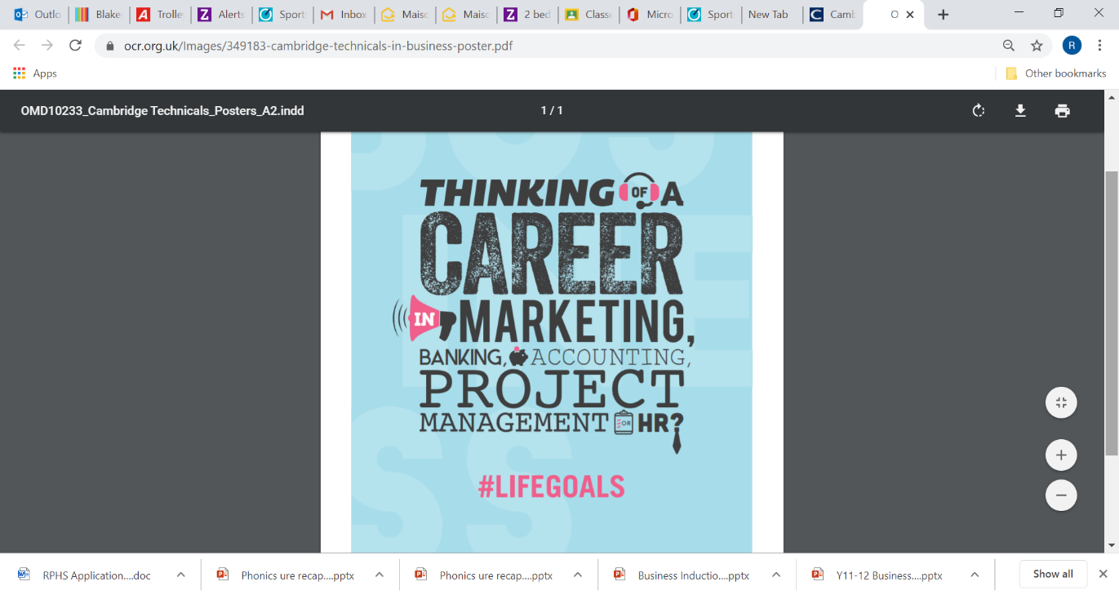

Welcome to Business Studies, one of the most international subjects in the world. Business Studies opens the doors to study a range of specialties such as accountancy, finance, organisation, human resources management or marketing. Studying Business will help you to appreciate the realities of managing a business, how to effectively manage and lead people, how to gain a competitive edge as a business person and how to recognise the principles of success.

**Overview of the course**

We offer an extended certificate qualification which is the equivalent of 1 A level. This is a two-year course which includes 2 examinations and 3 elements of coursework.

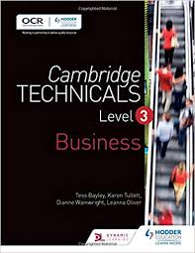

Text book used

ISBN: 9781471874796

|  |  |
| --- | --- |
| Year 12 | Year 13 |
| Unit 1 The Business Environment – exam  Unit 4 – Customers and communication - coursework  Unit 8 – Introduction to Human Resources - coursework | Unit 2 – Working in Business- exam  Unit 20 – Business Event Planning – practical event planning and coursework |

**Task 1: *Section A***

*Answer the questions that explore the themes of this unit, you will need to draw on your AO1 knowledge and understanding to support you in completing this.*

1. Identify one key objective of any start up business to achieve in the first year of trading
   1. Profit maximisation
   2. Cost minimisation
   3. Survival
2. Identify the formula for calculating profit
   1. Revenue – fixed costs
   2. Revenue – total costs
   3. Price – variable costs
3. What is the formula for calculating total revenue?
   1. Price x quantity
   2. (price – costs) x quantity
   3. Net profit/turnover
4. Which of the following is a PLC most likely to do with profits earned throughout the financial year?
   1. Pay out shareholder dividends
   2. Bulk buy stock for the next trading year
   3. Invest in training for its staff
5. An LTD typically receives additional funding by which means?
   1. IPO
   2. External investors in exchange for a share of the company
   3. Bank loans
6. Poolside Villas LTD wishes to offer an IPO. It has been advised to offer 500,000 shares at 125p each. What is the value of the ordinary share capital?
   1. £62,500,000
   2. £400,000
   3. £625,000
7. Identify the formula for Market capitalisation
   1. (Shares issued/initial share price) *100
   2. Ordinary shares issued x current share price
   3. Ordinary shares issued x original share price
8. A significant increase in competition within its market segment is likely to have what impact on the share price of a firm in the short run?
   1. An increase in share price
   2. Fall in share price
   3. No significant impact on share price
9. Current interest rates are 4.25% as set by the Bank of England. A significant rise in the interest rates is likely to see what impact on demand for general goods?
   1. No impact at all
   2. A small decrease in demand for goods
   3. A large decrease in demand for goods
10. A firm is looking to increase its use of fair trade goods and suppliers. This is likely to lead to:
    1. An increase in the cost of the products for the firm and consumers
    2. A decrease in the cost of the products for the firm and consumers
    3. No impact on costs for the firm

**Short Questions**

*Explain the following, each are worth 4 marks in total*

*Answer these questions, each of them are based on the unit of study but may draw from your wider reading.*

1. A firm posts record revenue figures for the trading year. Their profit levels however are below expectations. Explain why this would lead to a fall in share price

**(4)**

1. Explain one reason why UK firms tend to pay out dividends instead of re-investing in the long term future of the business

**(4)**

1. Explain one reason why being an LTD allows a firm more opportunity to diversify into ‘risky’ markets

**(4)**

1. Explain why survival tends to be the most important objective for a start-up business

**(4)**

1. Explain why a firm will need both mission statement and objectives

**(4)**

1. Explain why PLC firms in the UK tend to focus on profit maximisation above other objectives

**(4)**

1. Explain why a firm struggles to keep stakeholders happy during times of cost minimisation

**(4)**

1. Explain why an increase in inflation could affect demand for any business

**(4)**

1. Explain why a business funded on borrowed money would be concerned by the actions of the Bank of England.

**(4)**

1. Explain one reason how a recession could impact on consumer confidence

**(4)**

**Task 1 - Section B:**

**Finance Section:**

**Understanding business finance is hugely important when taking a business course in the sixth form. The next few tasks will allow you to demonstrate your knowledge and understanding and numeracy skills.**

Businesses would struggle to survive if they were not on top of their Accounting. As much as many large businesses pay Accountants to manage their finances, often this can be a very costly process for SMEs (can you look up the meaning of SMEs)?

Unit 1 includes a significant element of Financial Accounting in the exam. This is not ‘Maths’, but is more about interpreting the accounts of a business and how they are performing.

There are three financial statements that if researched in advance of starting the course, would really help you to get ahead of the game:

1. Income statements
2. Statement of financial position
3. Cash flow statements and forecasts



The financial performance of a business can be assessed using two key financial reports:

**Income statement (profit and loss account)**

* A formal financial document that summarises a business’ trading activities and expenses to show whether the business has made a profit or a loss over a specified period of time

**Statement of financial position (balance sheet)**

* A formal financial document that summarises the net worth of a business at a given point in time
* It balances net assets with total equity

Why do numbers matter?

Increasing profit is often a major aim for growing businesses. There are several ways in which this can be achieved

* + Sell the same quantity but at a higher price
  + Sell more at the current price
  + Sell the same at the same price but reduce costs

Businesses are not limited to one of these options but must realise each option has knock on implications

**Income Statements**

Profits are the surplus of revenue over costs

Profit = total revenue – total cost

There are 2 types of profit:

* + Gross profit
  + Operating profit

These are shown on an income statement (profit and loss account) which is a formal financial document that summarises a business’ trading activities and expenses to show whether it has made a profit or loss.

* + - 1. Write a list of possible expenses for a business.

|  |  |
| --- | --- |
| **Income statement** | £ |
| Sales revenue | £100 000 |
| Cost of sales | £45 000 |
| **Gross profit** | £55 000 |
| Other operating expenses | £32 000 |
| **Operating profit** | £23 000 |
| Interest and taxation | (£6 000) |
| Exceptional items | £0 |
| **Profit for the year (net profit)** | £17 000 |

**Above is an Income statement**

2: Rora Ltd is a tyre and exhaust centre. The table below shows data for month 1 of the financial year.

|  |  |  |  |
| --- | --- | --- | --- |
| Total sales | Cost of sales | Average expenses per customer | Number of customers |
| £225 000 | £75 000 | £35 | 1 500 |

* 1. What is Rora Ltd’s gross profit for month 1?

_____________________________________________________________________________________________________________________________________________________________________________________________

* 1. What is Rora Ltd’s gross profit margin for month 1?

_____________________________________________________________________________________________________________________________________________________________________________________________

* 1. What is Rora Ltd’s operating profit?

____________________________________________________________________________________________________________________________________________________________________________________________________________

* 1. What is Rora Ltd’s operating profit margin?

____________________________________________________________________________________________________________________________________________________________________________________________________________

3: Fawcett & Sons Ltd is a manufacturer of tractors. Use the information listed below to complete the key financial data table.

* Sales revenue in year 1 £21.2m
* Sales revenue in year 2 was 10% higher than year 1
* Cost of sales in year 1 30% of sales revenue
* Cost of sales in year 2 28% of sales revenue
* Expenses in year 1 £10.3m
* Operating profit in year 2 £11.1m

|  |  |  |
| --- | --- | --- |
| Key financial data for Fawcett and Sons Ltd | Year 1 | Year 2 |
| Sales revenue |  |  |
| Cost of sales |  |  |
| Gross profit |  |  |
| Expenses |  |  |
| Operating profit |  |  |

**Statement of financial position (balance sheet)**

This is a formal financial document that summarises the net worth of a business at a given point in time

* + It balances net assets with total equity
  + Net worth is if you took all of a business’ assets and turned them into cash and then paid off all of the businesses liabilities how much would be left?

4: What was Taylor Swift’s net worth in 2025? [Taylor Swift](https://www.forbes.com/profile/taylor-swift/)

---------------------------------------------------------------------------------------------------------------------------------------------------------------------------------------------------------------------------------------------------------------------------------------------------------------------------------------------------------------------------------

|  |  |
| --- | --- |
| **Assets: Items of value owned by a business.** | **Liabilities: Money a business owes i.e. debts.** |
| Non – current assets  Likely to be kept by the business for more than one year e.g.   * + - Vehicles     - Premises     - Machinery   Current assets  Likely to be turned into cash within a year e.g.   * + - Inventories     - Receivables     - Cash and cash equivalents | Non – current liabilities  Debts that the business has more than one year to repay e.g.   * + - Bank loans     - Mortgages   Current liabilities  Debts that the business may have to repay within one year e.g.   * + - Overdrafts     - Payables |

**Key Terms**

|  |  |
| --- | --- |
| **Non-current assets** | Long term or fixed assets |
| **Current assets** | Short term assets |
| Inventories | The value of stock held |
| Receivables | Cash owing from credit sales |
| Cash and cash equivalents | Cash in hand or at the bank |
| **Total current assets** | All current assets added together |
| **Current liabilities** | Money owed to be repaid in the short term |
| **Net current assets** | Total current assets minus current liabilities |
| **Non current liabilities** | Long term debts |
| **Net assets** | The net worth of the business’ assets |
| **Share capital** | Finance raised from the sale of shares |
| **Retained profit and reserves** | Cumulative profits kept in the business |
| **Total equity** | The value of shareholders’ funds |

**Below is a Statement of Financial Position**

|  |  |  |  |
| --- | --- | --- | --- |
|  | **£ms** | **£ms** | **Calculations** |
| **Non-current assets** |  | 19 550 |  |
| **Current assets** |  |  |  |
| Inventories | 2 375 |  |  |
| Receivables | 1 170 |  |  |
| Cash and cash equivalents | 2 300 |  |  |
| **Total current assets** |  | 5 845 | 2 375 + 1 170 + 2 300 |
| **Current liabilities** |  | 8 160 |  |
| **Net current assets** |  | (2 315) | 5 845 - 8 160 |
| **Non-current liabilities** |  | (6 000) |  |
| **Net assets** |  | **11 235** | 19 550 - 2 315 - 6 000 |
| **Share capital** |  | 6 000 |  |
| **Retained profit and reserves** |  | 5 235 |  |
| **Total equity** |  | **11 235** | 1. 000 + 5 235 |

5: Fill in the gaps to complete the statement of financial position for Zavolla Coffee Ltd.

|  |  |  |
| --- | --- | --- |
| Statement of financial position for Zavolla Coffee Ltd. | | |
|  | 2023 (£ms) | 2024 (£ms) |
| Non-current assets | 2.3 | 2.1 |
| Current assets |  |  |
| Stock | 0.5 | 0.4 |
| Debtors | 0.3 | 0.4 |
| Cash | 0.2 | 0.1 |
| Current liabilities | 0.6 | 0.4 |
| Non-current liabilities | 1.5 | 1.7 |
| Net worth |  |  |
| Share capital |  | 0.6 |
| Retained profit | 0.5 |  |
| Total equity |  |  |

Working capital is very important. It is a measure of a firm’s solvency / ability to meet day to day expenses.

**Working capital = current assets – current liabilities**

It is stated on the statement of financial position as net current liabilities or net current assets. Working capital answers the basic question if the firm had to pay off all its short term debts could it do so out of its short term cash resources i.e. inventories, payables and cash. If not then it will have to sell non-current assets to pay its debts and the business may cease trading e.g. if a limousine hire business has to sell its limousines it no longer has a business

6: Calculate the working capital for 2023 and 2024.

Workings

What is meant by equity? Can you explain in your own words?

**Task 2:**

**Business Detective**

**Objective:** Understand how real businesses operate.

**Instructions:**

Choose a local or well-known business (e.g., Greggs, JD Sports, or a local café).

Research and create a one-page profile that includes:

* What the business does (products/services)
* Who its customers are
* How it makes money
* One recent challenge it has faced (eg Marks and Spencer Cyber security problems )
* Present your findings as a mini case study or infographic.

**Skills Developed:**

Research, analysis, business awareness

**Task 3:**

**Third sector organisations and customer service**

Some businesses do not have profit as their main objective and instead seek to help a community or a certain sector of the population, e.g*. Shelter* is a charity to help the homeless and *The Big Issue* is a social enterprise which also helps the homeless but through trading rather than donations. Look at the website of The Big Issue and their video gallery.

The Big Issue Foundation <https://www.bigissue.org.uk/> their ‘About us’ page explains what The Big Issue is and how it aims to help the homeless through trade. The video gallery has short video clips about The Big Issue and how it helps the homeless through trade.

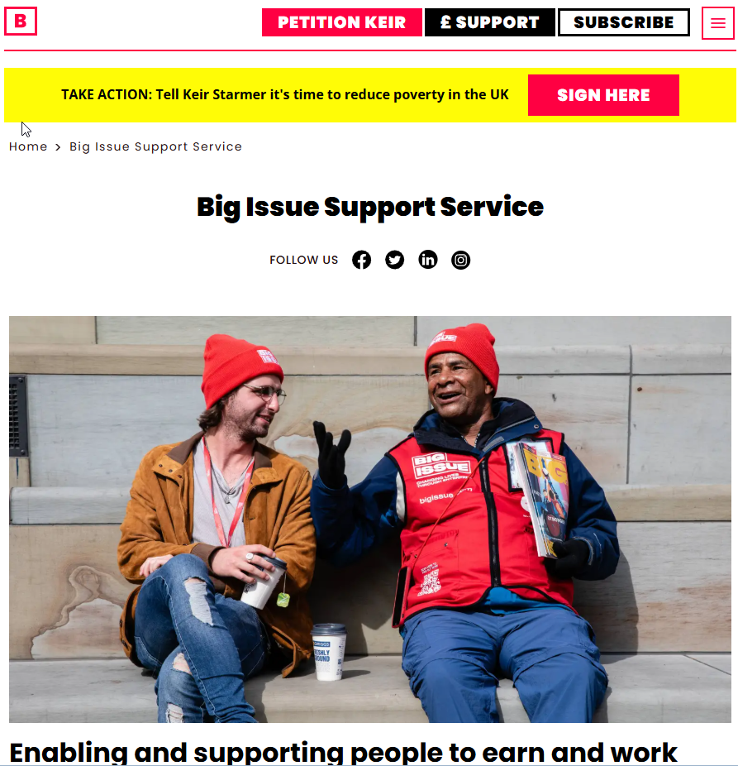

Write a 400-word report encompassing detail from The Big Issue and other enterprises you may come across in your research.

* How do these social enterprises use customer service to communicate their messages?
* How do they market/advertise their work?
* What makes them successful in their aim to support others?
* How do they raise funds?