Applied Science Transition Work

Task 1
- Draw and label particle diagrams of solid, liquids and gases including state changes

- Describe and explain how substances change state for: boiling, condensing, freezing, melting
__________________________________________________________________________________
__________________________________________________________________________________
__________________________________________________________________________________
__________________________________________________________________________________
__________________________________________________________________________________
__________________________________________________________________________________
__________________________________________________________________________________
__________________________________________________________________________________
__________________________________________________________________________________
__________________________________________________________________________________
__________________________________________________________________________________
__________________________________________________________________________________
__________________________________________________________________________________
__________________________________________________________________________________
__________________________________________________________________________________
__________________________________________________________________________________

Task 2
- Watch the video https://www.youtube.com/watch?v=LWCAEVIMt7g
Describe the method
__________________________________________________________________________________
__________________________________________________________________________________
__________________________________________________________________________________
__________________________________________________________________________________
__________________________________________________________________________________
__________________________________________________________________________________
__________________________________________________________________________________
__________________________________________________________________________________
__________________________________________________________________________________
__________________________________________________________________________________
__________________________________________________________________________________
__________________________________________________________________________________
__________________________________________________________________________________
__________________________________________________________________________________

- A scientist obtained some data from following the method. Plot the data onto the graph.

Time (minutes) | Temperature (°C)
0 | 10
5 | 20
10 | 30
15 | 40
20 | 50
25 | 60
30 | 65
35 | 70
40 | 70
45 | 70
50 | 75
55 | 80

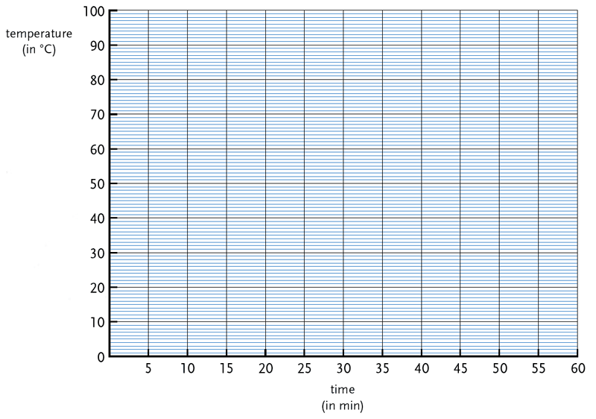Task 3
Evaluate the accuracy of: the method in the video from task 2, the data obtained in task b.
__________________________________________________________________________________
__________________________________________________________________________________
__________________________________________________________________________________
_________________________________________________________________________________
__________________________________________________________________________________
__________________________________________________________________________________
__________________________________________________________________________________
__________________________________________________________________________________
_________________________________________________________________________________
__________________________________________________________________________________
__________________________________________________________________________________
__________________________________________________________________________________
__________________________________________________________________________________
_________________________________________________________________________________
__________________________________________________________________________________

Additional space
__________________________________________________________________________________
_________________________________________________________________________________
__________________________________________________________________________________
__________________________________________________________________________________
__________________________________________________________________________________
__________________________________________________________________________________
_________________________________________________________________________________
__________________________________________________________________________________
__________________________________________________________________________________
__________________________________________________________________________________
__________________________________________________________________________________
_________________________________________________________________________________
__________________________________________________________________________________
__________________________________________________________________________________

