**Raynes Park Sixth Form - Year 11 to 12 Transition work Name:**

**Subject:** Cambridge Technical Diploma in Sport & Physical Activity

**Task 1**

Q1. Use the legislation titles below to then go and research the rest of the information to complete the fact files.

|  |  |
| --- | --- |
| Name: | Health and safety executive (HSE) |
| Date: | N/A |
| How does it keep people safe in sport? |  |

|  |  |
| --- | --- |
| Name: | Equality Act |
| Date: | 2010 |
| How does it keep people safe in sport? |  |

|  |  |
| --- | --- |
| Name: | Reporting of injuries, diseases and dangerous occurrences regulations (RIDDOR) |
| Date: | 1995 |
| How does it keep people safe in sport? |  |

|  |  |
| --- | --- |
| Name: | Data Protection Act |
| Date: | 1998 |
| How does it keep people safe in sport? |  |

|  |  |
| --- | --- |
| Name: | Disclosure Barring Service (DBS) |
| Date: | N/A |
| How does it keep people safe in sport? |  |

|  |  |
| --- | --- |
| Name: | Control of Substances Hazardous to Health (COSHH) |
| Date: | 2002 |
| How does it keep people safe in sport? |  |

**Task 2**

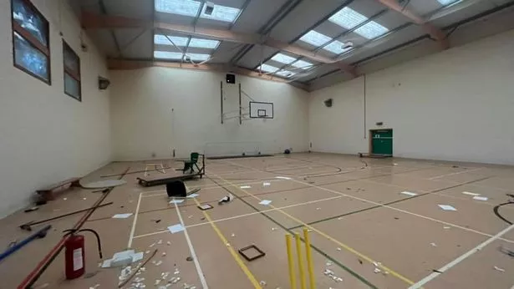

(Disclaimer: This is not our sports hall)

Q1. Circle 5 possible risks and add them to the risk assessment template below. Addhow severe the risk could be out of 4 and how likely it is to cause an injury out of 4. Then multiply these numbers to get your risk rating.

*(e.g. Severity – 3 X Likelihood – 2 = 3x2 = Risk rating 6)*

|  |  |  |  |  |  |  |  |  |  |  |
| --- | --- | --- | --- | --- | --- | --- | --- | --- | --- | --- |
| HAZARDS IDENTIFIED | | SEVERITY | | | | LIKELIHOOD/  PROBABILITY | | | | RISK  RATING |
| NO. |  | 1 | 2 | 3 | 4 | 1 | 2 | 3 | 4 | (1-16) |
| 1 |  |  |  |  |  |  |  |  |  |  |
| 2 |  |  |  |  |  |  |  |  |  |  |
| 3 |  |  |  |  |  |  |  |  |  |  |
| 4 |  |  |  |  |  |  |  |  |  |  |
| 5 |  |  |  |  |  |  |  |  |  |  |

**Task 3**

Q1. Exam Question example: Kasper is a fitness instructor. He is also a first aider at the fitness centre he works at. Describe Kasper’s responsibilities as a first aider when he is at work.

___________________________________________________________________________________________________________________________________________________________________________________________________________________________________________________________________________________________________________________________________________________________________________________________________________________________________________________________________________________________

_____________________________________________________________________________________________________________________________________________________________________________________________________________________________________________________________________________________________

_______________________________________________________________________________________________

_____________________________________________________________________________________________________________________________________________________________________________________________________________________________________________________________________________________________

___________________________________________________________________________________________________________________________________________________________________________________________________________________________________________________________________________________________________________________________________________________________________________________________________________________________________________________________________________________________

_____________________________________________________________________________________________________________________________________________________________________________________________________________________________________________________________________________________________

_______________________________________________________________________________________________

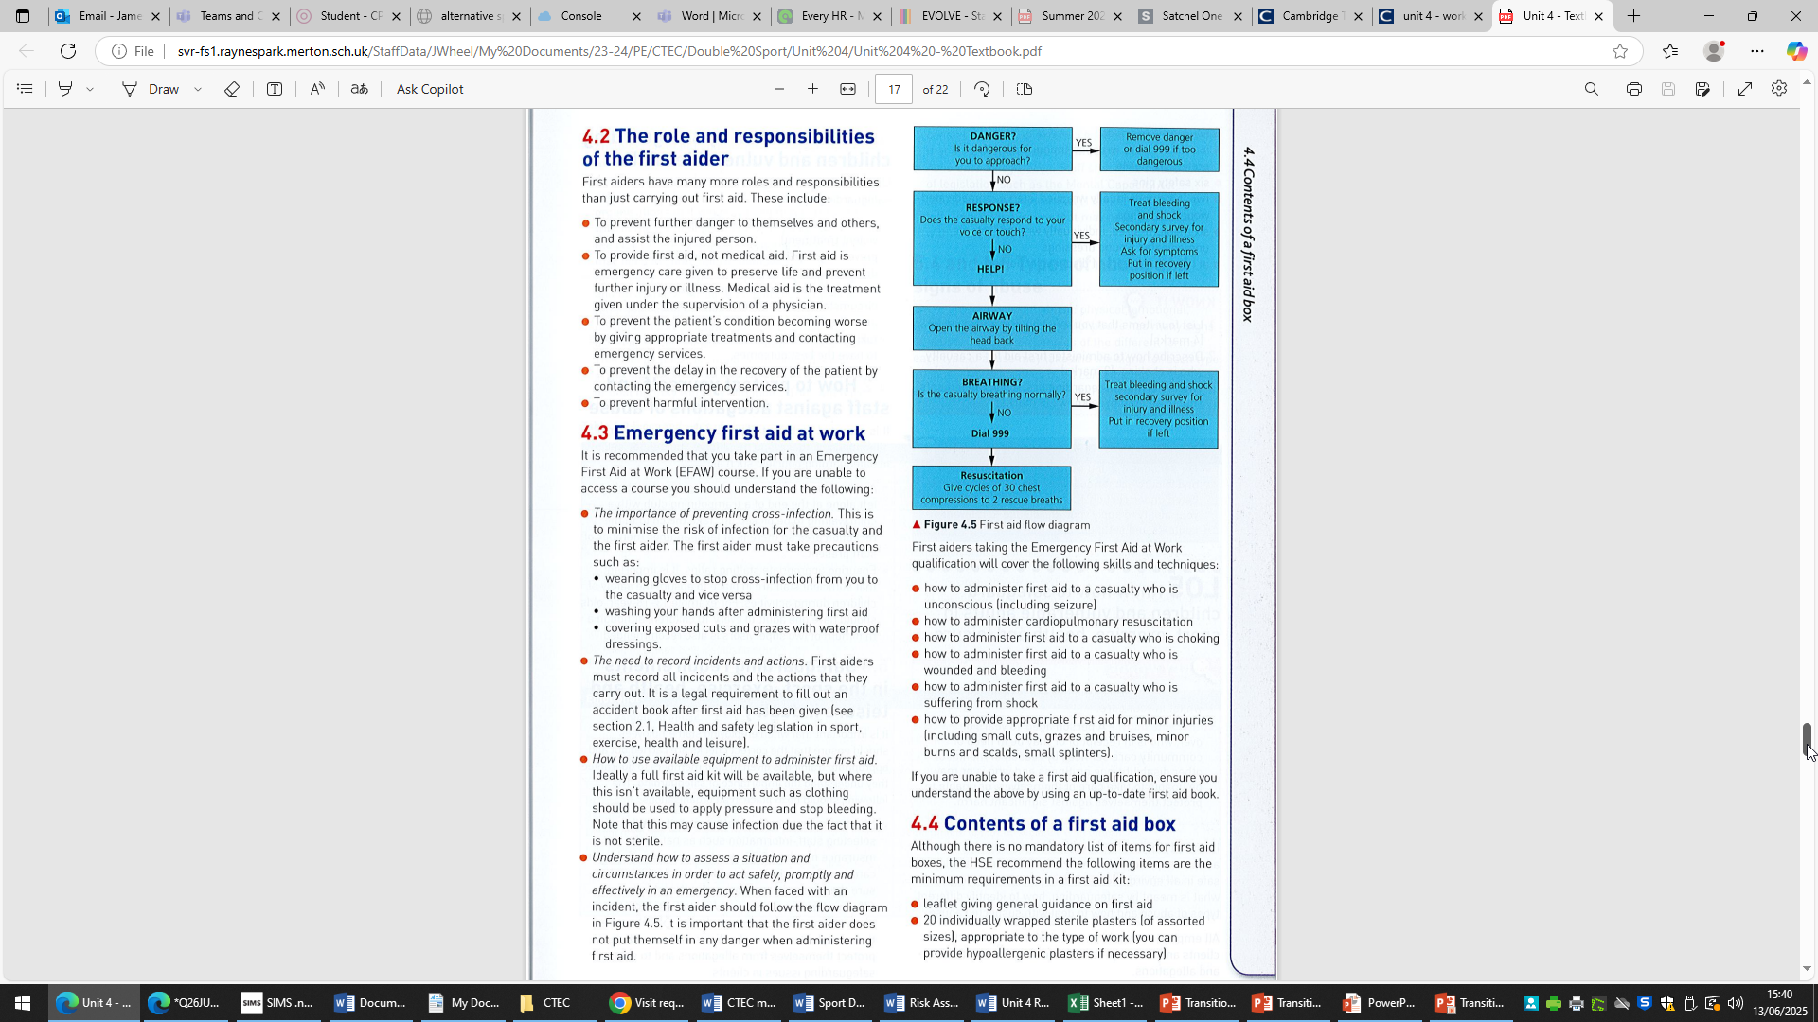

**Please submit this to your subject teacher in the first lesson in September.**