**Raynes Park Sixth Form - Year 11 to 12 Transition work**

**Subject:** Pearson BTEC Level 3 National Extended Certificate in Sound Engineering

**Task 1**

Q1. Match all of the components of this Audio Interface. Use the labels below.

(e.g.) POWER SWITCH

Turns the unit on and off

|  |  |  |  |
| --- | --- | --- | --- |
| Pad switch: Reduces mic gain by a large step For recording very loud sources | 48V “Phantom Power” For powering condenser mics [switch up = on] | Gain control for mic preamp to set recording level | Input level meters |
| Power switch | USB port Digital connection to computer | XLR mic inputs (fed from patchbay) | Mains power |
| MIDI I/O For connecting instruments which use original MIDI connectors | Main output Left & Right: Logic Main Mix goes from here to the monitor controller ‘mix’ input | Inputs also accept jack cables for Line Level signals |  |



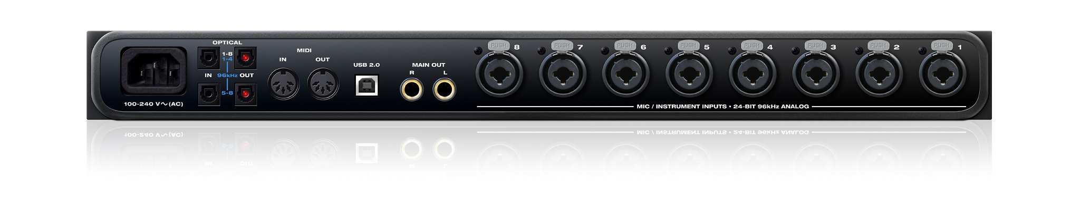

**Task 2**

Q1. Match the following studio components with their primary function.

|  |  |
| --- | --- |
| Component | Function |
| Audio Interface |  |
| Mixing Desk |  |
| Microphone |  |
| DI Box |  |
| Studio Monitors |  |
| DAW |  |
| XLR cable |  |
| TRS cable |  |

Task 3

**Q1.** Imagine you are recording a band. What microphone techniques would you use for:

|  |  |
| --- | --- |
| Vocals |  |
| Electric Guitar Amp |  |
| Acoustic Guitar |  |