**Raynes Park Sixth Form - Year 11 to 12 Transition work Name:**

**Subject:** Btec National Extended Certificate in 3D Art & Design

**Task 1**

A) Create 10 sketches of objects you have collected to help practice your understanding of form. These could include: pine cones, conkers, seeds heads, leaf skeletons, shells, fossils, fish, cross sections of fruit, vegetables,, feathers, butterflies, skulls and skeletons etc.

Please see examples below:

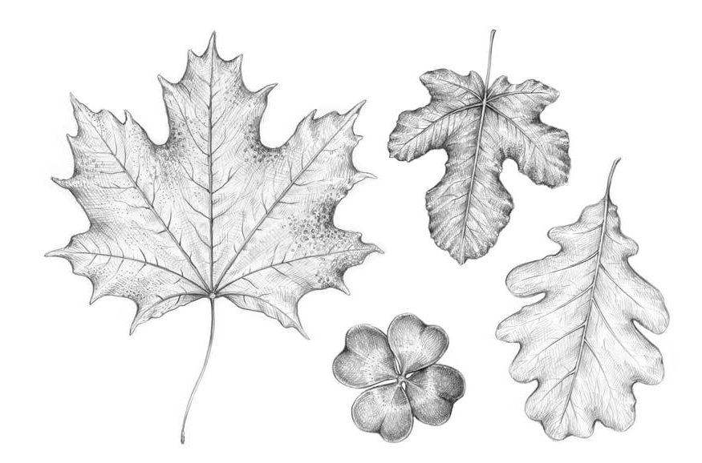

**Task 2**

A) Produce 20 photos of zoomorphic-based objects. These must be your own photos and not ones taken form the internet.

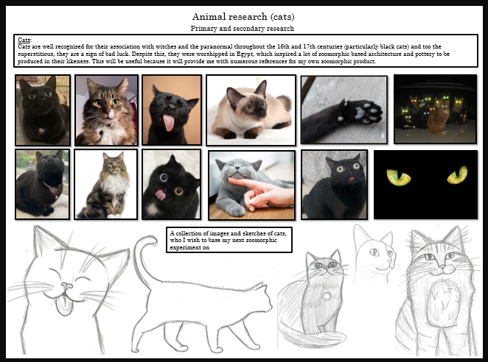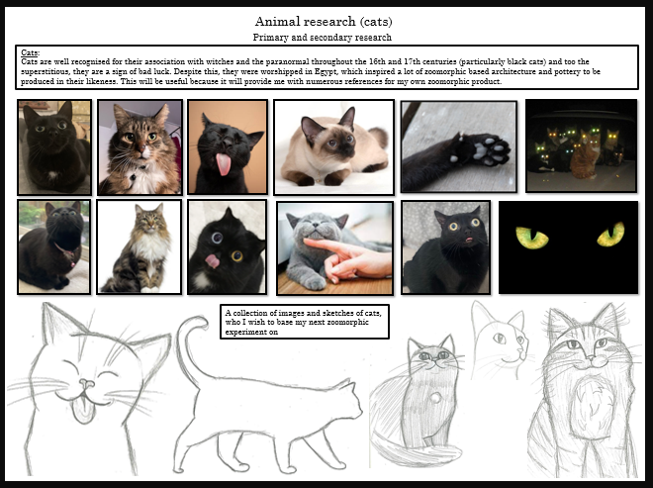

**Task 3**

1. Write a paragraph explaining what you think **Zoomorphic** is and how your perceive it meaning.

B) Write a paragraph explaining what **Zoomorphic** is and how you perceive it meaning.

________________________________________________________________________________________________________________________________________________________________________________________________________________________________________________________________________________________________________________________________________________________________________________________________________________________________________________________________________________________________________________________________________________________________________________________________________________________________________________________________________________________________________________________________________________________________________________________

**Please submit this to your subject teacher in the first lesson in September.**