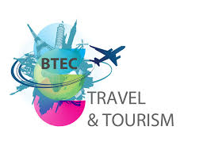

**BTEC Level 3 National Extended Certificate in Travel and Tourism**

**Student name: ________________________________**

This booklet must be completed by the first day back in September.

This work can be completed on a PC or printed off and hand written.

Hello! Welcome to Travel and Tourism. Please don’t worry if you have never studied Travel and Tourism before. We are here to guide you through the course and to build your confidence within this new subject!

Travel and Tourism

Subject Enhancement work

There are some tasks that we would like you to complete before starting the course in September.

**1. Starting out!**

A good place to start is with your own experiences of travel and tourism. Complete the table below.

|  |  |
| --- | --- |
| Question | Answer |
| Where did you or someone you know go on holiday last? |  |
| Was it in the UK or abroad? |  |
| How did you/they get there? |  |
| What type of accommodation did you/they stay in? |  |
| What activities did you/they do whilst you were there? |  |
| What did you/they eat and drink? |  |
| How was the holiday organised/booked? |  |

**2. Key terminology**

Find the definition for the key terms below. Provide examples, where possible.

|  |  |
| --- | --- |
| Travel |  |
| Tourism |  |
| Domestic Tourism |  |
| Inbound Tourism |  |
| Overseas Tourism |  |
| Public Sector |  |
| Private Sector |  |
| Voluntary Sector |  |
| Travel Agent |  |
| Tour Operator |  |
| Seasonality |  |
| External Factors |  |
| Internal Factors |  |
| Exchange Rate |  |
| Currency |  |
| Visitor Attraction |  |
| Customer Service |  |
| Insurance |  |
| Trade Association |  |

**3. Tourism in the UK**

**Mapping Tourist locations in the UK**

(This task can be completed on PC or printed and completed by hand)

On the map of the UK label the following:

Plot on the map

* 3 airports and their 3 letter codes
* 3 seaports and their 3 letter codes
* The Eurostar termini in the UK
* The 4 capital cities
* 6 seaside resorts

Remember to include a key

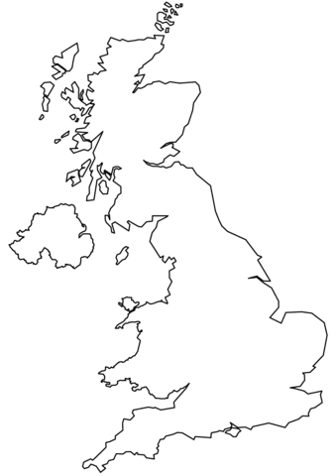

**4. Visitor Attractions.**

Our coursework in Year 2 focuses on Visitor Attractions. Complete the table below on the different types of visitor attraction. Think about places you have visited first.

|  |  |  |  |
| --- | --- | --- | --- |
| **Type of attraction** | **Local example (within 15 miles of Raynes Park)** | **National Example (In the UK)** | **Overseas Example** |
| Stately Home |  | Blenheim Palace Oxfordshire, England. |  |
| Theme Park | Chessington world of adventures |  |  |
| Garden |  |  |  |
| Museum |  |  |  |
| Art Gallery |  |  |  |
| Event |  |  |  |
| Sports Venue |  |  |  |
| Resort |  |  |  |
| Heritage |  |  | Taj Mahal, India |

Visit The Tripadvisor website: What are the 15 most popular visitor attractions in London?

Why would a website such as Tripadvisor be useful for tourists coming to visit the area?

Where else can we find out about visitor attractions? Can you think of 5 different sources? (name specific sources e.g. Tripadvisor is a specific website.

What are the needs of customers? Complete the table below. Use the examples to help you.

|  |  |  |  |
| --- | --- | --- | --- |
| Customer Type | Needs at the airport | Needs within accommodation | Needs with visitor attractions |
| Family with young children | Baby change facilities  Priority boarding  Buggy pick up from the plane |  |  |
| Disabled visitor in a wheelchair |  |  |  |
| Elderly Couple |  | Ground floor accommodation |  |
| School Group |  |  | Lunch room  Tour guides  Education packages |
| A family who don’t speak English |  |  |  |
| A honeymoon couple |  |  |  |

Customer Service

Give 5 reasons why customer service is important

1.

2.

3.

4.

5.

Give 3 problems that may occur if customer service is not good

1.

2.

3.

Give 3 ways in which travel and tourism companies can improve their customer service.

1.

2.

3.

**Conclusion**

**How can tourism be made more sustainable?**

Select 4 ways in which tourism can be made more sustainable.

* Create more permanent jobs.
* Reduce plastic consumption.
* Invest the income into local projects.
* Improve the infrastructure.
* Develop cultural links.
* Increase the number of flights.
* Use local materials in tourism projects.
* Encourage the sale of locally made produce.

**Principles of Sustainable Tourism**

“Sustainability means meeting our own needs without compromising the ability of future generations to meet their own needs”

Select the 4 correct principles of sustainable tourism

* Minimise negative environmental impacts in a destination.
* Reduce litter and consumption of plastics.
* Create economic benefits, including future employment, for local people.
* Create employment for overseas tour guides.
* Conserve local culture.
* Build new infrastructure.
* Promote links and respect between tourists and local communities.
* Increase political power.
* Reduce the number of flights taken in 1 year.

**Business tourism**

What does MICE stand for, select the correct word in each list

M: Macro, Meeting, Museum, Milestone

I: Initiative, Iceland, Incentive, Igloo

C: Conference, Collusion, Course, Cave

E: Education, Exhibition, Election, Execution

**Dark Tourism – circle the examples and complete the definition**

Dark tourism involves _____________ to places ______________ with __________and _____________.

Suffering, travelling, associated, death

Chernobyl The Louvre Tate

Auschwitz Ypres Battlefield Disneyland

9/11 Memorial Great Wall of China

**Business tourism**

What does MICE stand for, select the correct word in each list

M: Macro, Meeting, Museum, Milestone

I: Initiative, Iceland, Incentive, Igloo

C: Conference, Collusion, Course, Cave

E: Education, Exhibition, Election, Execution

**Gross Domestic Product – Give a Definition**

**Final task**

2 A4 page research task

You have been tasked by a local newspaper to write an article about a holiday destination of your choosing. The article must contain reason why the destination is appealing, current tourist trends and suggestion on how the destination might change in the future. Other than that you are free to write about anything you deem important.

(write on lined paper or typed in PC).