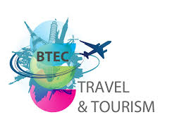

**BTEC Tech Award Level 1-2 in Travel and Tourism**

**Student name: ________________________________**

This booklet must be completed by the first day back in September.

This work can be completed on a PC or printed off and hand written.

Hello! Welcome to Travel and Tourism. Please don’t worry if you have never studied Travel and Tourism before. We are here to guide you through the course and to build your confidence within this new subject!

Travel and Tourism

Subject Enhancement work

There are some tasks that we would like you to complete before starting the course in September.

**1. Starting out!**

A good place to start is with your own experiences of travel and tourism. Complete the table below.

|  |  |
| --- | --- |
| Question | Answer |
| Where did you go on a holiday? |  |
| Was it in the UK or abroad? |  |
| How did you? |  |
| What type of accommodation did you stay in? |  |
| What activities did you/they do whilst you were there? |  |
| What did you/they eat and drink? |  |
| How was the holiday organised/booked? |  |

**2. Key terminology**

Find the definition for the key terms below. Provide examples, where possible.

|  |  |
| --- | --- |
| Travel |  |
| Tourism |  |
| Domestic Tourism |  |
| Inbound Tourism |  |
| Overseas Tourism |  |
| Public Sector |  |
| Private Sector |  |
| Voluntary Sector |  |
| Travel Agent |  |
| Tour Operator |  |
| Seasonality |  |
| Exchange Rate |  |
| Currency |  |
| Visitor Attraction |  |
| Customer Service |  |
| Insurance |  |
| Trade Association |  |

**3. Tourism in the UK**

**Mapping Tourist locations in the UK**

(This task can be completed on PC or printed and completed by hand)

On the map of the UK label the following:

Plot on the map

* 3 airports and their 3 letter codes
* 3 seaports and their 3 letter codes
* The Eurostar termini in the UK
* The 4 capital cities
* 6 seaside resorts

Remember to include a key

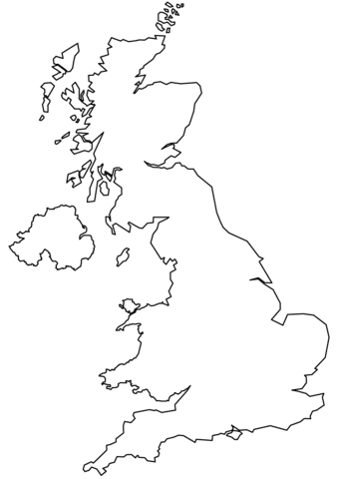

**4. Visitor Attractions.**

Our coursework in Year 2 focuses on Visitor Attractions. Complete the table below on the different types of visitor attraction. Think about places you have visited first.

|  |  |  |  |
| --- | --- | --- | --- |
| **Type of attraction** | **Local example (within 15 miles of Raynes Park)** | **National Example (In the UK)** | **Overseas Example** |
| Stately Home |  | Blenheim Palace Oxfordshire, England. |  |
| Theme Park | Chessington world of adventures |  |  |
| Garden |  |  |  |
| Museum |  |  |  |
| Art Gallery |  |  |  |
| Event (eg: Music festival) |  |  |  |
| Sports Venue |  |  |  |
| Resort |  |  |  |
| Heritage |  |  | Taj Mahal, India |

**5. What are the needs of customers?**

Complete the table below. Use the examples to help you.

|  |  |  |  |
| --- | --- | --- | --- |
| Customer Type | Needs at the airport | Needs within accommodation | Needs with visitor attractions |
| Family with young children | Baby change facilities  Priority boarding  Buggy pick up from the plane |  |  |
| Disabled visitor in a wheelchair |  |  |  |
| Elderly Couple |  | Ground floor accommodation |  |
| School Group |  |  | Lunch room  Tour guides  Education packages |
| A family who don’t speak English |  |  |  |
| A honeymoon couple |  |  |  |

**6. Sustainable Tourism Report**

**Your task:**

Choose an existing example of a sustainable tourism resort anywhere in the world. Then complete a short written report (can be typed) that explains what makes the resort sustainable.

**What to include in your report:**

1. **What is sustainable tourism?** *Define sustainable tourism and explain why it is important.*
2. **Which resort did you choose?** *Write the name of the resort and locate it (country and region); add in a map/photo (optional).*
3. **How is the resort sustainable?** *Accommodation (how are the buildings and rooms eco-friendly?); Activities (what activities do tourists do that are good for the environment or local culture?; Community (how does the resort support local people or traditions?)*
4. **What do you think?** *What is the thing that this resort does really well?; Is there anything you think it can improve?*