AQA A-Level Biology Transition Work

# Task 1

1. Hand-label the cell diagrams to show the organelles and describe their functions

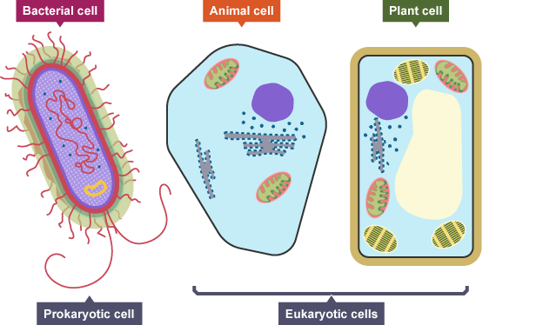

1. Describe the functions of the different parts of a microscope on the diagram.

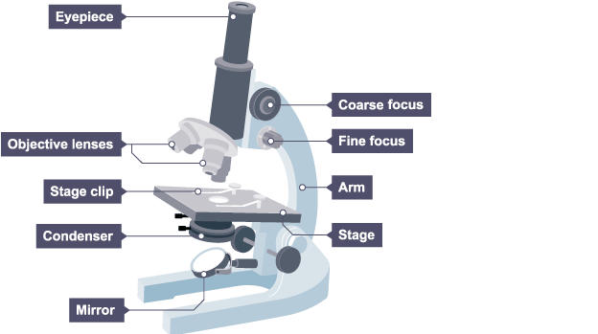

# Task 2

1. Compare the structure of a eukaryotic cell with a prokaryotic cell by completing the Venn diagram.

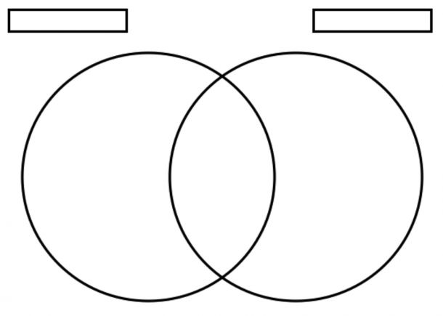

1. Compare and explain the images produced and uses of light, SEM and TEM microscopes.

__________________________________________________________________________________

__________________________________________________________________________________

__________________________________________________________________________________

__________________________________________________________________________________

__________________________________________________________________________________

__________________________________________________________________________________

__________________________________________________________________________________

__________________________________________________________________________________

__________________________________________________________________________________

__________________________________________________________________________________

__________________________________________________________________________________

__________________________________________________________________________________

__________________________________________________________________________________

__________________________________________________________________________________

# Task 3

1. Draw a labelled diagram of the structure of a cell membrane
2. Describe the fluid mosaic model

__________________________________________________________________________________

_________________________________________________________________________________

__________________________________________________________________________________

__________________________________________________________________________________

__________________________________________________________________________________

__________________________________________________________________________________

1. Evaluate the fluid mosaic model

__________________________________________________________________________________

_________________________________________________________________________________

__________________________________________________________________________________

__________________________________________________________________________________

__________________________________________________________________________________

__________________________________________________________________________________

_________________________________________________________________________________

__________________________________________________________________________________

__________________________________________________________________________________

__________________________________________________________________________________

__________________________________________________________________________________

_________________________________________________________________________________

__________________________________________________________________________________

__________________________________________________________________________________

__________________________________________________________________________________

__________________________________________________________________________________

_________________________________________________________________________________

__________________________________________________________________________________

__________________________________________________________________________________

__________________________________________________________________________________

__________________________________________________________________________________

_________________________________________________________________________________

__________________________________________________________________________________

__________________________________________________________________________________

__________________________________________________________________________________

Additional space

__________________________________________________________________________________

_________________________________________________________________________________

__________________________________________________________________________________

__________________________________________________________________________________

__________________________________________________________________________________

__________________________________________________________________________________

_________________________________________________________________________________

__________________________________________________________________________________

__________________________________________________________________________________

__________________________________________________________________________________

__________________________________________________________________________________

_________________________________________________________________________________

__________________________________________________________________________________

__________________________________________________________________________________