ONCE A Criminologist, ALWAYS A Criminologist!
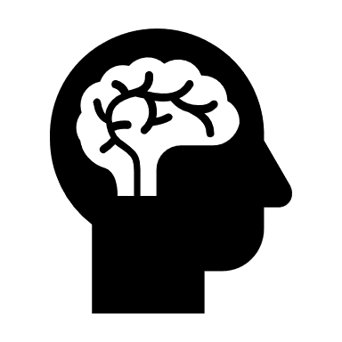
The following are suggestions, they are not compulsory, but we would love for you to engage in any that you find interesting.
- 1984 – George Orwell
- Folk Devils and Moral Panics – Stanley Cohen
- A Glasgow Gang Observed – Patrick James
- Gang Leader For A Day – Sudhir Venkatesh
- Fake Law – The Secret Barrister

 | https://www.wjec.co.uk/qualifications/criminology-level-3/#tab_keydocuments  https://resources.wjec.co.uk/pages/ResourceByArgs.aspx?subid=93&lvlid=1  https://www.independent.co.uk/topic/criminology  www.theguardian.com/education/sociology  www.nytimes.com/topic/subject/sociology  www.tutor2u.net/sociology/blog  www.nortonbooks.typepad.com/everydaysociology/  www.soc.washington.edu/news | https://journals.sagepub.com/home/crj  https://theconversation.com/uk/topics/criminology-890  https://www.cbsnews.com/crime/  https://www.theguardian.com/uk/ukcrime  www.sociologysal.blogspot.com  www.gendersociety.wordpress.com  www.creativesociology.blogspot.com  www.sociologylens.net  www.blogs.lse.ac.uk/impactofsocialsciences/

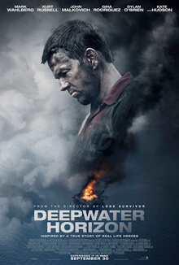
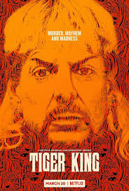
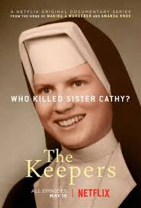
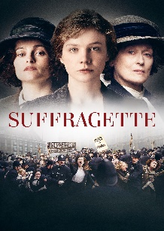
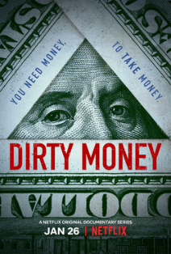
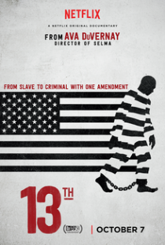

 | Criminology True crime podcast (Spotify)  Killer queens – a true crime podcast (Spotify)  British murders (Spotify)  Serial productions by new York times (Spotify)  S-Town hosted by Brian Reed and the NY Times (Spotify) | Tedtalks  The real routes of violence Craig Pinkney (youtube)  Uncaged from prison to purpose by Michael Maisey (youtube)  Identity, Intersectionality, and Representation in the Digital Space | Jasmine Le (youtube)

- 24hours in police custody (channel 4)
- Forensic scientists (ITV Hub)
- The Innocence Files (Netflix
- Cold Case Files (Netflix)
- I Am A Killer (Netflix)
- When They See Us Now – Oprah Winfrey (Netflix)

