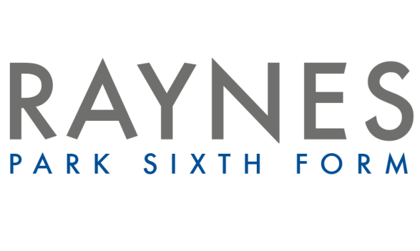

Psychology Transition Booklet
(Essential)
What does Pavlov use to wash his hair?
Classical conditioner!

Psychology: the scientific study of the human mind and behaviour
Psychology A-Level: Pre Study Information.

Please work through the following tasks to prepare you for September. This will need to be submitted in the first lesson.

You will need to purchase the first of the two text books required for the course:

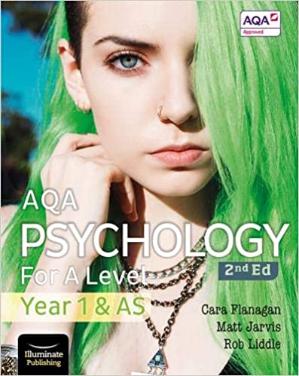
- AQA Psychology for A-Level Year 1 & AS 2nd Edition Student Book
ISBN: 978-1912820429
Approx £26 (may be cheaper on Amazon)

Psychology A-Level: Summer Transition Work

Task 1
There are some core approaches to Psychology that you need to know for your A level – these are different ways of explaining human behaviour. Some of these are listed below. Your task is to do some research on them using the internet.

The five main approaches in Psychology.
- Behaviourist
- Cognitive
- Biological
- Psychodynamic
- Humanistic
For each approach, create an information fact sheet including the answer to the following key questions:
- What does the word mean (eg. behaviourist approach)
- What are the main assumptions of the approach (eg. we are born a blank slate and we learn from our environment.)
- Who is/are the key psychologist for this approach (may be more than one)
- Which key studies or case studies provide support for this approach? Give a brief outline of what they did and what they found?
- What are the limitations to this approach?

Useful Starting Points

Overview of the approaches in Psychology:
- http://www.simplypsychology.org/a-level-approaches.html

Podcasts

Behaviourist Approach
- BF Skinner and Superstition in the Pigeon
- http://www.bbc.co.uk/programmes/b0639gxq

Cognitive Approach
- Sir Frederic Bartlett – The War of the Ghosts
- http://www.bbc.co.uk/programmes/p00f8n47

Biological Approach
- The Man with a Hole in His Head
- http://www.bbc.co.uk/programmes/b00bcccq

Humanistic Approach
- Abraham Maslow and the Hierarchy of Needs
- http://www.bbc.co.uk/programmes/b01rw8mw

Task 2
Key Psychological Studies
Below are some links to some important Psychological studies for you to read.
For each of the five studies listed below summarise the following in 100-150 words:

- Background and Aim(s)
- Method (procedure and details of the sample)
- Results (this could be written or included on a graph – as long as you explain your graph)
- Conclusion(s)

This information is called ‘A01’. It is all about describing or outlining something. This may be describing a study, an explanation or a model.

This element of the question will begin…. AO1 = Describe, Identify, Outline etc.

- https://simplypsychology.org/milgram.html - Milgram
- https://www.simplypsychology.org/zimbardo.html - Zimbardo
- https://www.simplypsychology.org/loftus-palmer.html - Loftus and Palmer
- https://www.simplypsychology.org/mary-ainsworth.html - Ainsworth
- https://www.simplypsychology.org/bowlby.html - Bowlby

Key Research Quiz
- How many participants were there in Milgram’s study?
- 20
- 40
- 50
- 60
- What was the speed estimate when the verb ‘smashed’ was used?
- 40.6mph
- 48.1mph
- 40.8mph
- 41.8mph

- What role did Zimbardo play in the Stamford prison experiment?
- A guard
- A prisoner
- A warden
- The chief superintendent

- How were the prisoners for Zimbardo’s study ‘collected’?
- Arrested at home and handcuffed by police officer
- Arrested at home by Zimbardo
- They made their own way to Stamford University for the experiment
- Arrested at home by the guards in the study

Task 3
For this task you need to set up a free Tutor2u account, using your email address. Once you have set this up, you are to enrol on the FREE introduction to AQA A-level Psychology course. This will introduce you to the structure of the course and how you will be assessed. Once you have done each task please mark as complete.
Please make a note of your tutor2u account details as we use there free resources regularly.
https://ondemand.tutor2u.net/students/introduction-to-aqa-a-level-psychology

