ONCE A BIOLOGIST, ALWAYS A BIOLOGIST!
The Biology department would love for you to continue to stay cognitively engaged over the coming weeks in preparation for your A-Level Biology course. The following are suggestions for you to engage in any that you find interesting. They are not compulsory but are really interesting!
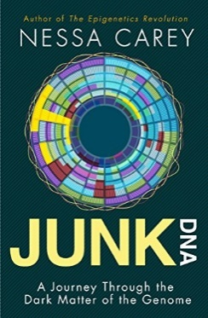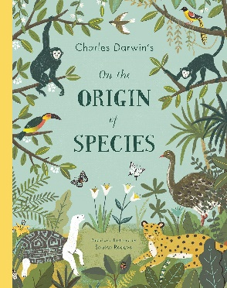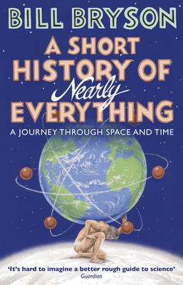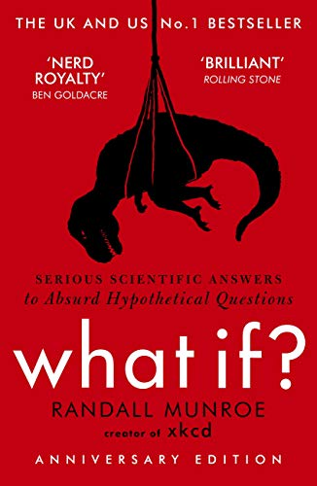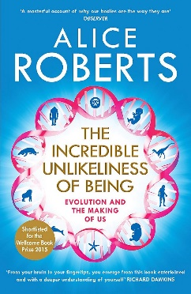

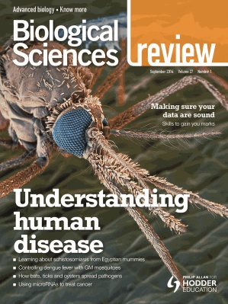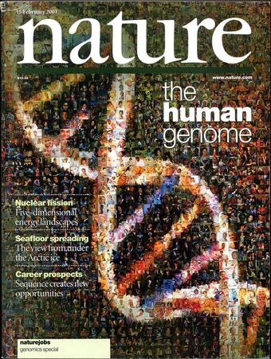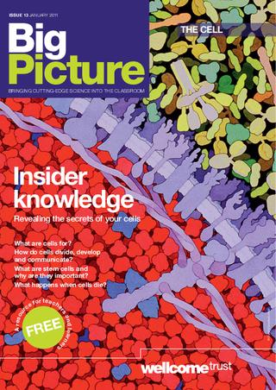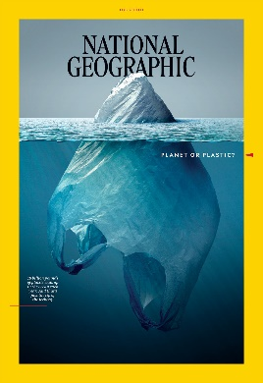

60 Second Science
https://www.scientificamerican.com/podcast/60-second-science/
Science Weekly podcast
https://www.theguardian.com/science/series/science
Research based podcasts
https://www.nature.com/nature/articles?type=nature-podcast

Virtual Natural History Museum
https://www.nhm.ac.uk/visit/virtual-museum.html
Interviews with Research Biologists about topic issues
https://thebiologist.rsb.org.uk/biologist-interviews
Ted Talk A New Superpower in the fight against cancer https://www.ted.com/talks/paula_hammond_a_new_superweapon_in_the_fight_against_cancer?language=en
The Royal Institution on all aspects of Science
https://www.youtube.com/user/TheRoyalInstitution
A collection of short research articles and opinion pieces
https://royalsocietypublishing.org/journal/rsbl
A regularly updated blog from The Royal Institution
https://www.rigb.org/blog

