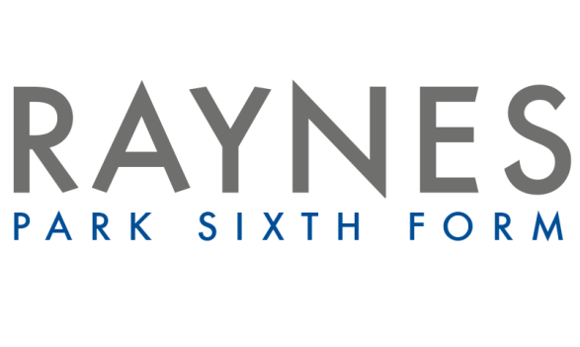

Psychology Transition Booklet
(Desirable)

Task 1

AQA Psychology includes many of the math’s skills you used at GCSE and these must not be forgotten. Psychology maths questions can appear in any of the 3 papers. The following questions are here to make you familiar with the mathematical content for the course.

Rounding to Decimal Places

Round to 1 decimal place
a) 0.374
b) 0.798
c) 0.393
d) 0.584

Round to 2 decimal places
e) 0.136
f) 0.138
g) 0.464

Round to three decimal places

h) 29.9757
i) 46.2317
j) 79.0919

Rounding to Significant Figures

Round to 1 significant Figure

- 15
- 983
- 0.0097
- 1.9

Round to 2 significant Figures

- 0.133
- 0.0403
- 90054

Round to 3 significant figures

- 0.6402
- 160.7

Task 2

Psychological Disorders

This task is to explore Psychology in the real world by looking at 1-2 of the following disorders. For the disorder create fact sheet including: what is the disorder? What are the causes of the disorder? How are these disorders treated?

- Obsessive-Compulsive Disorder (OCD)
- Schizophrenia
- Depression
- Antisocial Personality Disorder (APD)

Task 3

Below are just some of the key terms we will be using in Psychology in terms of Research Methods. Create your own key word glossary by adding the definition:
(you will add to this as the course progresses)

Key Term | Definition
Aim
Case Study
Content Analysis
Correlation
Control Group
Confounding Variables
Covert Observation
Overt Observation
Debriefing
Dependent Variable
Demand Characteristics
Directional Hypothesis
Non Directional Hypothesis
Validity
Ecological Validity
External Validity
Face Validity
Independent Variable
Internal Validity
Operationalised Variables
Primary Data
Secondary Data
Qualitative Data
Quantitative Data
Reliability
Sign Test
Sample
Type 1 error
Type 2 error
Meta-analysis

Task 5

Choose a Psychological podcast to listen to from the following (for some you will be able to choose an area that interests you, however please read the senopsis carefully to make sure that you are comfortable with the topic area):

https://www.bbc.co.uk/programmes/b006qxx9
https://www.bbc.co.uk/sounds/play/b06rzd44
https://www.bbc.co.uk/sounds/brand/b008cy1j
https://scottbarrykaufman.com/podcast/
https://www.bbc.co.uk/programmes/p094py21
Write a brief review of the main points of the podcasts
- What did you learn?
- What would you like to learn more about?
- Would you recommend this podcast to a future Year 12 student and why?

