**Criminology – Desirable**

**Preparatory Summer Work**

Task 1

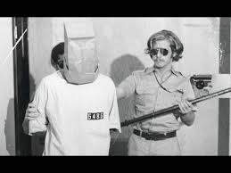Watch this documentary on **Zimbardo** and The Stanford Prison Experiment. Consider if you think it was the ‘Prison’ which changed the participant’s behaviour or the personality of those in the ‘prison’. <https://www.youtube.com/watch?v=F4txhN13y6A>

Task 2

There are hundreds of books written about true crime. These are available in your local library, online, as an audio or kindle book or in shops. Perhaps even on one of the bookshelves in your own home. Find one that catches your interest and read it during the summer holidays.

What book did you read and what fascinated you about it?

Task 3:

**Can you spot a killer** from an innocent person? Are their certain characteristics that are genetic that means you will become a criminal? Are some people born evil? Lombroso was a theorist who helped found modern day psychological profiling and he believed your facial features gave crucial clues as to whether you were born to be a criminal.

Or is it down to how we are nurtured? Are criminals created as a result of the environment they grow up in? Bandura believed we learned our criminal behaviour through peer and family observation. Much like a child learns from watching those around them.

Look at the images below and see if you recognise any of them. Can you find out who they all are and what they did?

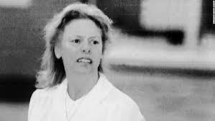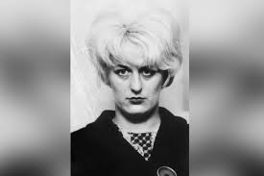

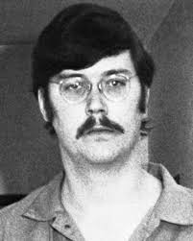

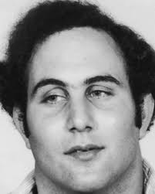

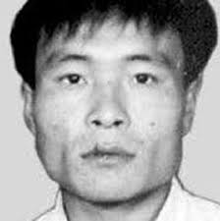

Task 4

Familiarise yourself with the WJEC exam board that your criminology course is with [www.wjec.co.uk](http://www.wjec.co.uk)

Look at the course specification, past exam papers and mark schemes and the examiner’s reports.

The specification gives the topics we look at and explains more about expectations of the course, including the all-important controlled assessments in units 1 and 2.

Write down any questions that you have, after looking at these documents, so that we can answer them when you start the course…

***Nature vs Nurture – The Big Debate***





There are many ways of explaining why certain people do things in certain ways. For example, biologists think that people behave as they do because they are controlled by nature. This is known as **Nature theory**. Humans are compared to animals and are seen to act on **instinct**.

Sociologists believe that people behave as they do because they are taught how to behave. For example, the sociologist Michael Haralambos states, ‘Human beings learn their behaviour and use their intelligence whereas animals simply act on instinct.’ This is known as **Nurture theory**. Nurture is the way you are brought up. It is also a reference to **socialization**, the lifelong process by which we learn our culture, values, norms and how to behave.

Task 5

Research the childhood backgrounds of any notorious serial murderers such as Fred West or Harold Shipman. The focus should be on life history and not subsequent crimes. Thinking about what you have read about Nature and Nurture, which explanation could account for their criminal behaviour?

Please only use reputable sources for this and consider who you choose carefully. You may wish to discuss this with your parents/ carers.

|  |
| --- |
| **Essay title:**  To what extent did childhood experiences either indicate developing problems or appear to contribute to the later offending behaviour?  You will need to select a criminal to write about and pay particular attention to what you have read about nature and nurture. Further research will also be required. |

Your essay should have:

* Clear paragraphs, an introduction and conclusion
* Accurate spelling, punctuation and full sentences
* Correct use of grammar
* Accurate phrasing
* A discussion of BOTH nature and nurture, explaining which theory best suits the behaviour of the criminal you have chosen to write about.
* Your essay should be at approx. 500 words.