Welcome to KS5 BTEC 3D Design Essential work

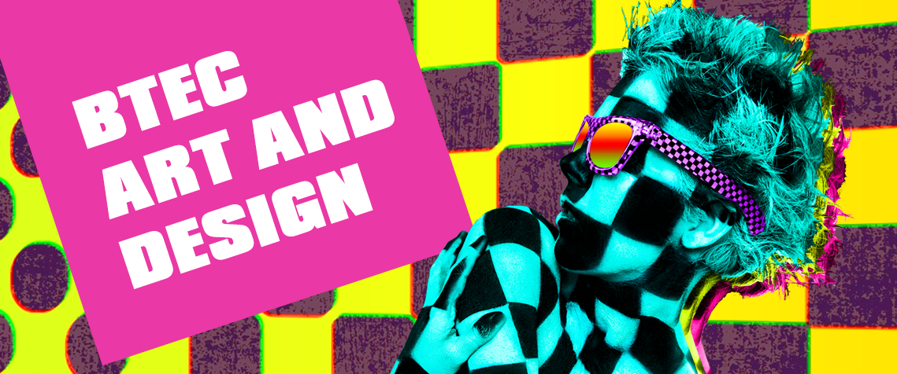
3D DESIGN

Welcome to 3D Design. This course covers a wide range of different design areas and disciplines, literally everything that is designed for, and in, three dimensions from electronic goods to cars and bikes, from architecture and interior design to packaging, from handmade craft goods to exhibition and museum design. The course will also give you the opportunity to appreciate the work of other artists and designers and to learn about associated professional practice.

Overview of the course

BTEC Art and Design 3D Design is the equivalent to an A-Level. It is a two-year course which includes 4 units. You will study the following units:

Year 12 | Year 13
Unit 1 – Visual Recording and Communication  Unit 13 – 3D Design Materials, Techniques and Processes | Unit 2 – Critical and Contextual Studies in Art and Design  Unit 3 – The Creative Process

To prepare you for the 3D Design course you need to undertake the tasks detailed below, they are separated into two main categories, research and designing. All work must be printed and presented in an A3 folder and submitted in your first lesson.

Research and investigation

Task 1: Materials research. To ensure you are up to speed with key knowledge you are required to research and present information on the following:

● Metals. Ferrous, non-ferrous and alloys including examples of metals from each category.
● Polymers. Thermosetting, thermoforming and biodegradable including examples of polymer in each category.
● Woods. Hardwoods, softwoods and manufactured boards including examples of each.

Task 2: Designer research.

Research the following designers:

● Phillipe Starck
● James Dyson
● Margaret Calvert
● Dieter Rams
● Charles and Ray Eames
● Marianne Brandt

For each provide key information on the designer and a range of examples of their work.

Task 3: Design movement research.

● Arts and crafts
● Art deco
● Modernism (e.g Bauhaus)
● Post modernism (e.g. Memphis)

For each provide a description of the movement/era and show example designs that represent each era.

Task 4: Manufacturing research.

● 3D Printer
● Laser cutter
● Computer-Aided Design Software
● Post modernism (e.g. Memphis)

For each provide a description of the how it works and what it is used for.

Designing
You are to undertake a short design project on the theme of seating. These will be conceptual, we are focussing on the aesthetics and the presentation. This will consist of four tasks, detailed below:

Task 1: Decide who your target market will be and the type of seating you are going to design.

Task 2: A mood board. A mood board is used to inspire and inform your designing. This must consist of images of a range of products, materials and textures, not just images of seating. The mood board must fill one A3 page.

Task 3: Initial ideas. On one A3 page, sketch out a minimum of 8 initial designs for seating. The emphasis here is on sketches, not time consuming drawings. They should show imagination and creativity and use a variety of techniques (3D isometric, 3D oblique, 2D using multiple views, 2-point perspective) and media (tone using just pencil, designs sketched in one coloured pencil or pen, fine line using thick and thin lines, full colour). This must be presented on one A3 page.

Task 4: Developed design. Choose one of your initial ideas and develop this into a feasible, high quality solution. This must be presented in detail with an explanation of the design and materials labelled. You can either draw this by hand or use a computer design package of your choice.
