Health and Social Care
Essential Work

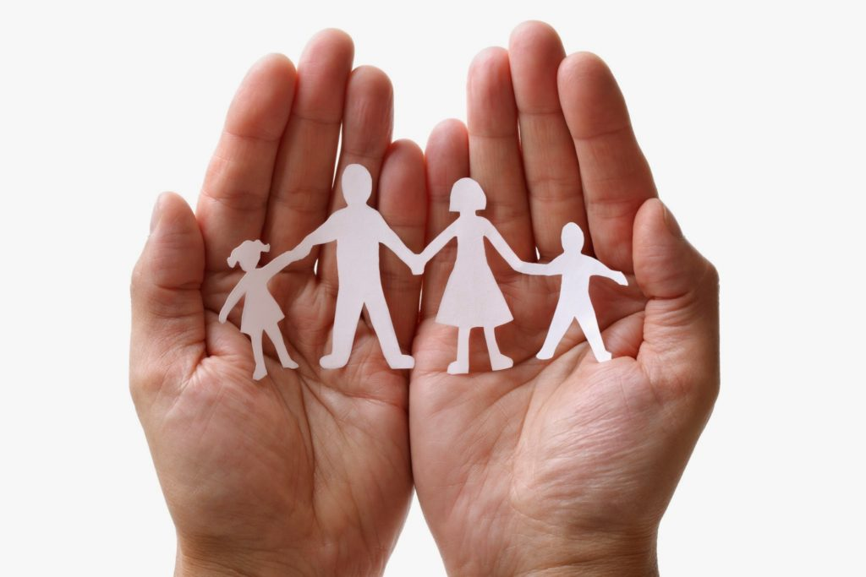

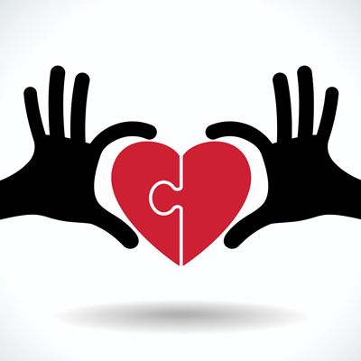
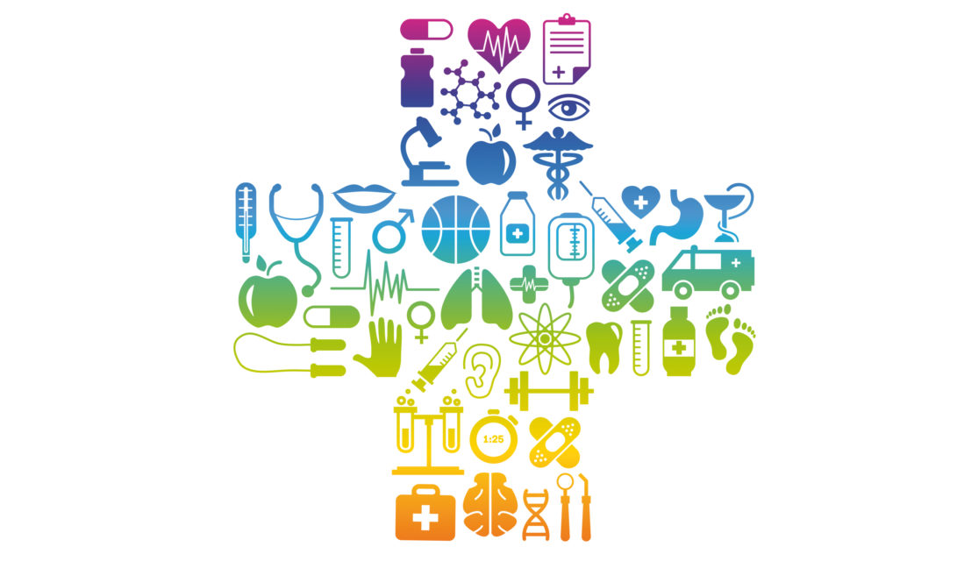
Health and Social Care is a vocational subject offering you an insight into one of the most important areas of work.
Interesting facts and figures
- The NHS in England employs 1.26 million full time equivalent staff in England, as of Nov 2022. Making it one of the largest employers in the world.
- There are around 128,452 full-time equivalent doctors, and over 350,000 nurses in the NHS.
- The social care sector employs approx.1.5 million people

What you will study:
Extended Certificate (equivalent to 1 A-Levels)
You will study the following units;
- Building positive relationships in health and social care
- Equality, diversity and rights in health and social care
- Health, safety and security in health and social care
- Anatomy and physiology for health and social care
- Supporting people with mental health conditions
- Sociology for health and social care
Diploma (equivalent to 2 A-levels)
You will study the following units;
- Building positive relationships in health and social care
- Equality, diversity and rights in health and social care
- Health, safety and security in health and social care
- Anatomy and physiology for health and social care
- Infection control
- Personalisation and a person-centred approach to care
- Safeguarding
- Promote positive behaviour
- Sexual health, reproduction and early development stages
- Supporting people with mental health conditions
- Caring for older people
- Sociology for health and social care
Unit one Building Positive Relationships. To deliver safe and effective care and support professionals must work together. This involves studying how these relationships are formed and maintained.
Maddie is a 6-year-old girl; she was playing with her friends in the park and attempted to complete the monkey bars by herself. She fell to the ground landing awkwardly; banging her head. She was initially knocked unconscious but now she has come round and is in a lot of pain and it looks like she has broken her leg.
Maddie is lucky because she lives in the United Kingdom where the welfare state will support her treatment and recovery. List the different types of services that will be available to Maddie as she recovers. Challenge; decide which ones are health care services, social care services or child care services. What do you notice about the number and variety of different services?
________________________________________________________________________________________________________________________________________________________________________________________________________________________________________________________________________________________________________________________________________________________________________________________________________________________________________________________________________________________________________________________________________________________________________________________________________________________________________________________________________________________________________________________________________________________________________________________________
These services must all work together. Fill in the diagram on the next page. Add a description of how someone from each category could support Maddie on her road to recovery. Challenge: annotate onto the diagram how and why it is important that they have a positive relationship with each other, to enable Maddie to receive the best care.

B Communication skills. When building positive relationships effective communication skills are vital. Explain what each of these skills involves.
Skill | Definition
Tone and pitch

Pace

Eye contact

Facial expressions

Gestures

Volume

Posture

Imagine you are a nursery nurse working with young children. You are going to perform for them a popular children’s rhyme or song such as incy wincy spider, twinkle twinkle little star, 5 little ducks or even Peter Rabbit had a fly upon his nose (it can be any of your choice.)
- Firstly perform the song / rhyme using no communication skills whatsoever.
- Next perform the song/rhyme using the skills you have defined in your table
What difference does using communication skills have on your performance? Why do you think it is so important for professional such as nursery nurses to use effective communication skills?
________________________________________________________________________________________________________________________________________________________________________________________________________________________________________________________________________________________________________________________________________________________________________________________________________________________________________________________________
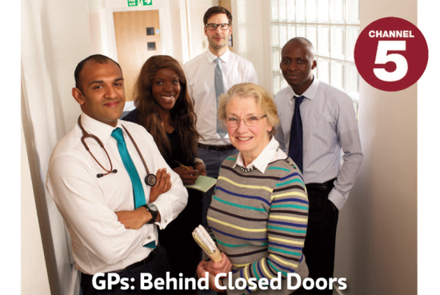
GP behind closed doors https://www.my5.tv/gps-behind-closed-doors
Watch an episode of this program and analyse the strategies the doctors use to build up positive relationships with their patients and deliver the best possible care. Challenge: explain the impact of the strategies. Consider;
- The verbal communication skills such as tone, pitch, pace, volume, choice of language/words
- The non-verbal communication skills such as eye contact, facial expressions, gestures and posture
- The management of environmental factors such as how they construct a supportive and positive environment

Category | Strategy | Impact
Verbal communication skills

Non-verbal communication skills

Environmental factors

Why is it important for GPs to develop positive relationships with service users?
________________________________________________________________________________________________________________________________________________________________________________________________
Unit 2 Equality and Diversity
Equality “We all have one thing in common we are all unique”. Equality is when all individuals are treated fairly; according to their needs and, given the same opportunities regardless of differences.
Diversity means acknowledging and respecting the differences between different people and cultures.
The Equality Act states that there are a total of 9 protected characteristics which must not be discriminated against.
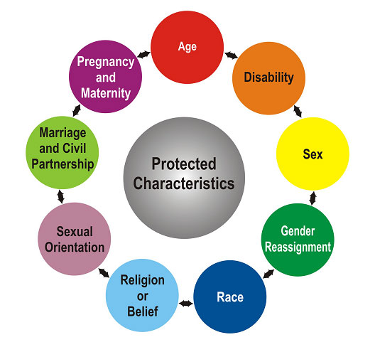
For one of these protected characteristics explain how a care setting of your choice could demonstrate that they value individuals with that particular characteristic.
________________________________________________________________________________________________________________________________________________________________________________________________________________________________________________________________________________________________________________________________________________________________________________________________________________________________________________________________________________________________________________________________________________________________________________________________________________________________________________________________________________________________________________________________
Unit 3 Health and Safety
Hazards are things which have the potential to cause harm. We study the hazards identified in this table. You have one example, add more.
Hazard | Definition | Examples
Environmental | Things in the area around you that may not have been maintained well | Slipping on a wet floor in a care home bathroom
Biological | Natural waste products and bodily fluids that can spread infections | Vomit from a child in a nursery play area
Chemical | Where there is the potential for exposure to Chemicals such as cleaning agents and medication | An unlocked medicine trolley in a hospital
Psychological | Things which has the potential to harm a person’s mental health and well-being | Tiredness caused by high workload
Musculoskeletal | Things which have the potential to injure the musculoskeletal system and effect the body’s movement | Moving heavy people in and out of bed without the winch/equipment
Working conditions and practices | Conditions refer to the environment a person is expected to work in. Practices include policies that particular workplaces put into place | People working double shifts when there are staff shortages in a hospital
Lack of security systems | Equipment and strategies to prevent unauthorised access or harm to the individuals receiving care the settings themselves and the equipment/resources within them. | Faulty smoke alarms in a crèche
Annotate the pictures below by identifying the hazards and where possible labelling which type of hazard it is.

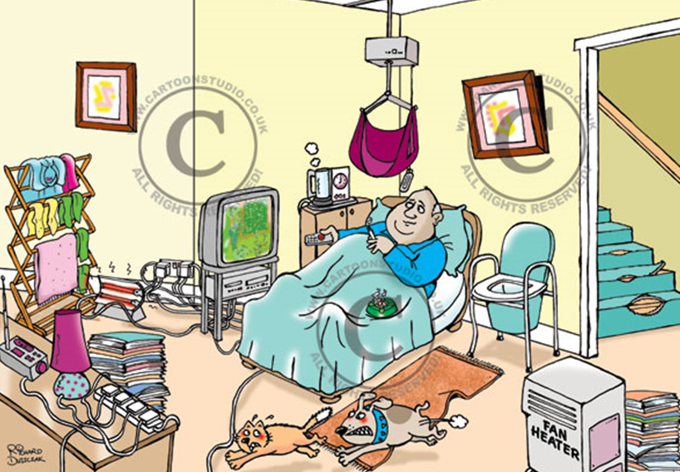

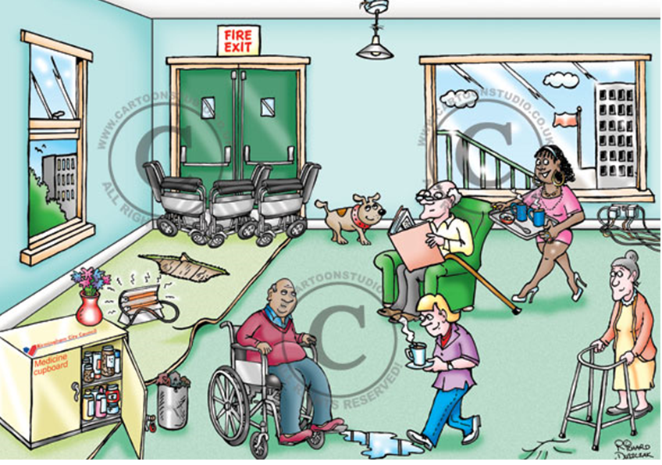

Response to hazards
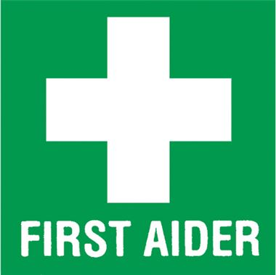
Once a hazard has caused harm and someone has become ill or injured a first aider will be called upon. Using the following link give advice to a new first aider what they would do in the following situation. www.sja.org.uk/get-advice/i-need-to-know/the-role-of-the-first-aider/

Three Children in a care home were making a meal for themselves and their care worker without supervision. One of the children cut themselves severely with a knife while chopping vegetables. Their friend turned to look and in shock dropped a pan of boiling water on the floor, which splashed up over their feet. When the first aider arrives what should they do?

Step 1
____________________________________________________________________________________________________________________________________________________________________________________________________________________________________________________________________
Step 2
____________________________________________________________________________________________________________________________________________________________________________________________________________________________________________________________________
Step 3
____________________________________________________________________________________________________________________________________________________________________________________________________________________________________________________________________
Step 4
____________________________________________________________________________________________________________________________________________________________________________________________________________________________________________________________________

Unit 4 Anatomy and Physiology
True or False?

- The human body’s biggest organ is the skin
- The adult human body has over 500 bones:
- Baby girls are born with 2 millions eggs inside them:
- The name of the substance that gives skin and hair its’ colour is called Iron
- The ribs are the bones around your chest that protect organs such as the heart
- Eyes are usually the same size
- It is estimated that the human body have 60,000 miles of blood vessels:
- Men’s hearts beat faster than women's
- The appendix has no purpose in the human body:
- You only need one kidney to stay alive and live a normal life:
- 60% of The human body is made up of water:
- It takes a maximum of 24hours for food to be fully digested:
- Lungs can clean and heal themselves:

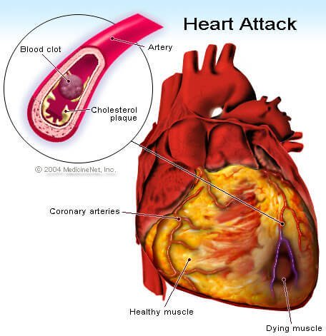
Produce a fact sheet on heart attacks www.nhs.uk/conditions/heart-attack/
Causes and risk factors
________________________________________________________________________________________________________________________________________________________________________________________________
Symptoms
________________________________________________________________________________________________________________________________
Diagnosis and Monitoring
________________________________________________________________________________________________________________________________________________________________________________________________
Treatments
________________________________________________________________________________________________________________________________________________________________________________________________
________________________________________________________________
Effects: Challenge categorise them into physical, emotional, social
________________________________________________________________________________________________________________________________________________________________________________________________
________________________________________________________________________________________________________________________________________________________________________________________________
________________________________________________________________________________________________________________________________________________________________________________________________

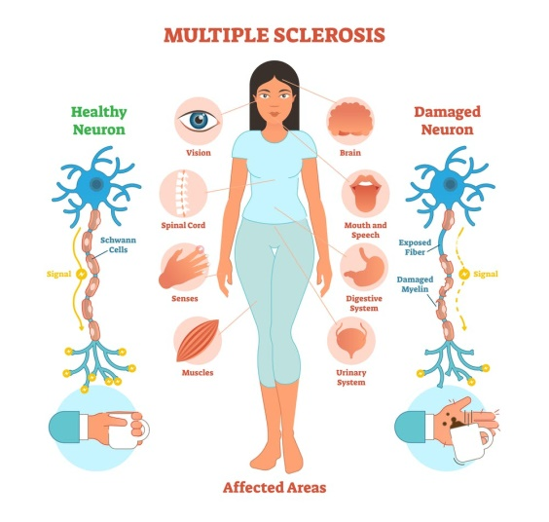
Multiple sclerosis
According to the NHS “Multiple sclerosis (MS) is a condition that can affect the brain and spinal cord, causing a wide range of potential symptoms, including problems with vision, arm or leg movement, sensation or balance. It's a lifelong condition that can sometimes cause serious disability, although it can occasionally be mild.
Produce a fact sheet on living with multiple sclerosis include:
- Causes and risk factors
- Signs and symptoms
- Treatment and monitoring
- Effects on individuals: challenge divide into PIES and compare between individuals

Unit 17 Supporting People with Mental Health Conditions
Mental health is defined as a state of well-being in which every individual realizes his or her own potential, can cope with the normal stresses of life, can work productively and fruitfully, and is able to make a contribution to her or his community. (WHO).
According to Mind, approximately 1 in 4 people In the UK will experience a mental health problem each year.
Research 2 mental health conditions, using reputable sites eg. NHS and Mind.
- Describe the disorder?
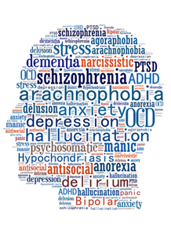
- The causes, treatments, support and effects
- Explain the treatment options for the disorder?
Types of conditions
- depression and post-natal depression
- anxiety
- bipolar
- schizophrenia,
- psychosis
- obsessive-compulsive disorder
- phobias
- body dysmorphia
- eating disorders

