Welcome to KS5 BTEC 3D Design Desirable work

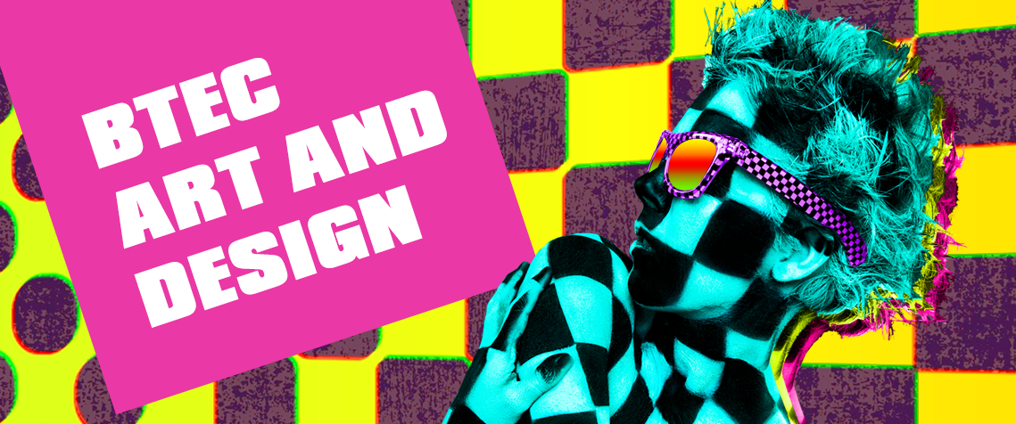
3D DESIGN

To further prepare yourself for the 3D design course it is recommended that you are also fully engage with the design world. Although this is optional preparation it will put you in a stronger position to succeed in the course. To assist you with this there are three areas in which you should look into; creative careers, creative activities, core skill development.

Creative careers
Whether you're designing ships as a naval architect or creating cutting edge art as a fine artist, the one thing that all jobs in this family have in common is creativity. So if you're an ideas person and you like creating things that are useful and visually appealing, take a look at some of these jobs.

Art editor | Cabinet maker | Arts administrator
Bookbinder or print finisher | Dressmaker | Upholsterer
Design engineer | Fashion designer | Ceramics design-maker
Exhibition engineer | Furniture designer | Costume designer
Footwear designer | Graphic designer | Ergonomist
Glassmaker | Interior designer | Fine artist
Illustrator | Make-up artist | Furniture restorer
Landscape architect | Museum curator | Hat designer
Model maker | Photographic stylist | Jewellery designer-maker
Prop maker | Set designer | Medical illustrator
Visual Merchandiser | Textile designer | Pattern cutter
Web designer | Art therapist | Product designer

Have a look at these websites to find out more about creative careers:
National Careers Website
https://nationalcareers.service.gov.uk/explore-careers
BBC Bitesize careers
https://www.bbc.co.uk/bitesize/careers

Creative activities
It helps if you….
• Understand technical drawing.
• Record ideas and observations through photography.
• Visit galleries and exhibitions regularly.

Book recommendations
Design Museum: Contemporary Design
Catherine McDermott

Process: 50 Product Designs from Concept to Manufacture Paperback – 25
Jennifer Hudson

The Eco-Design Handbook
Alastair Faud –Luke

Designs of the Times
Lakshmi Bhaskaran

Arts & Crafts Companion Pamela Todd Bauhaus
Benedict Taschen

Memphis
Bigitte Fitoussi

The Measure of Man and Women: Human Factors in Design
Alvin R. Tilley & Henry Dreyfuss Associates

Ideas for day trips
Tate modern
Tate Britain
National Gallery
National Portrait
Gallery Saatchi Gallery
Victoria and Albert Museum
Royal Academy of Arts
The Barbican
Victoria Miro
Whitechapel Gallery

Core skill development
1.Produce 10 designs for different objects that you are interested.
• Use a range of media – pencil, markers, digital, paint, pen etc.
• Draw a range of angles of your objects and try different drawing techniques such as; 2-point perspective, isometric, orthographic drawings.
• Work on loose pieces of paper or a drawing pad and collate your ideas together.
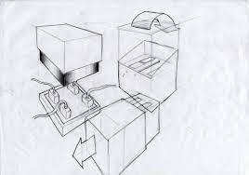
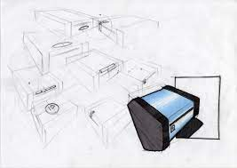
2. Watch these videos showing design creation using different techniques. Come back to class ready to show what new skills you have acquired.
Product design
https://www.youtube.com/watch?v=bjEw-mulcjA
https://www.youtube.com/watch?v=FLrCO4K2Wkw

Transport design
https://www.youtube.com/watch?v=raSdMU4nB2s
https://www.youtube.com/watch?v=X-HT_rw6chk

Furniture design
https://www.youtube.com/watch?v=LOU1zCbrCXQ
https://www.youtube.com/watch?v=fy3dZIQJs1U

