Cambridge Technicals Level 3

IT

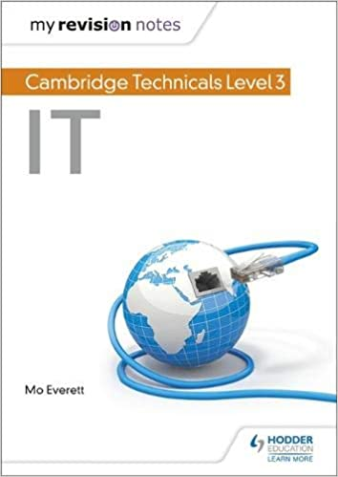

Name :

Date :

Please submit your completed work to Mr. Jackson

djackson@raynespark.merton.sch.uk

**Section 1 – System Development Life Cycle**

The system life cycle is used to explain what happens during each stage business application e.g. a new mobile App, a new car, a new smart phone etc

<https://www.teach-ict.com/as_as_computing/ocr/H047/F451/312/slc_cycle/miniweb/pg5.htm>

Task: Complete the table below of the system life cycle.

|  |  |
| --- | --- |
| Definition: | |
| Investigation and analysis |  |
| Design |  |
| Implementation |  |
| Testing |  |
| Installation |  |
| Documentation |  |
| Evaluation |  |
| Maintenance |  |

**Section 2 – Game Development**

The course consists of game development and application development.

Task: Produce a report on the possible games that can be developed using the platforms below. Also, you need to look at the advantages and disadvantages for each platform.

|  |  |
| --- | --- |
| <https://unity.com/> | <https://www.unrealengine.com/en-US/> |
| List the types of games that can be created using this platform. | List the types of games that can be created using this platform. |
| Advantages  Disadvantages | Advantages  Disadvantages |

|  |  |  |
| --- | --- | --- |
| Appshed  AppShed Game Maker is a platform for beginners (and experts) to build HTML5 games. | | |
|  | Register using the starter account.  <https://appshed.com/appbuilder/login/register>  Instructions to create the game  <https://appshed.com/create/game-maker> | Game Maker is part of the AppShed platform. The games you build become part of your app. Your apps can include a combination of app items (content) and games. You can easily Publish and Share your apps allowing others to play your games. Simply follow the instructions for Publishing, and then share the URL/web link with friends or post on social media.  Game Maker is built for education and learning. The aim is to provide learners with a simple interface and enjoyable experience while they get to grips with important concepts of computational thinking and coding. |
| Name of app:  Purpose for the app:  Features of the app:  Print screen of the final app: | | |

**Section 3 – Error Message Task**

**TASK** Read the error messages carefully and complete the table

Adapted from Teach-ict.com

|  |  |  |  |  |  |
| --- | --- | --- | --- | --- | --- |
| **Error message** | **What do you think the message means?** | | **Either tell your ICT teacher or the network technician** | | **Deal with it yourself** |
|  |  | |  | |  |
|  |  | |  | |  |
|  | |  | |  |  | |
|  | |  | |  |  | |
|  | |  | |  |  | |
|  | |  | |  |  | |

**Section 4 – Information storage media**

There are a number of different methods of storing large amounts of data, from traditional paper-based methods to modern magnetic hard drives.

**Mutability** is a key word that means whether a storage device can have its data changed or whether it is read-only. A **mutable device can be overwritten** but an **immutable device is permanent and read-only** once data has been added.

**Magnetic Storage**

Traditional computers will contain a **hard disk drive** which is an example of magnetic storage. There are two 'heads' that spin and access data on the disk. A **write-head** changes data and a **read-head** accesses the data. Magnetic tape and floppy disks are further examples of magnetic storage, but they are no longer used often.

​

* 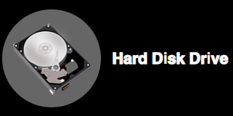**Capacity**: **Large storage space**, from 500 MB up to 4 TB.
* **Durability**: Because of moving parts, it is **fragile if moved**.
* **Portability**: Because of moving parts, they are **not easy to move** around.
* **Mutability**: Magnetic storage is **mutable** and data can be**rewritten**.
* **Speed of access**: **Relatively quick to access**.

​

**Suitable for**: Storing a lot of information and backing up data, because of its high

capacity.

**Optical Storage**

Optical storage uses laser technology to project beams of light onto a disk. If light is reflected then the data is recorded as 1, no reflection records a 0. In this method, lasers can write to and read from a disk.

​​

* **Capacity: 650 MB (CD), 9GB (DVD), 50 GB (Blu-ray).**
* 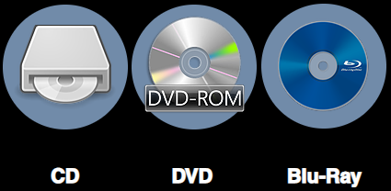**Durability: Disks are very fragile and break / scratch easily.**
* **Portability: Thinness makes it very easy to transport.**
* **Mutability: Optical storage is immutable - it is read-only.**
* **Speed of access: Relatively slow access speed.**

​

**Suitable for**: Storing multimedia files such as music,

pictures and videos.

**Solid State Storage**

This technology is named as such because there are no moving parts. Because of its low power use and quick access speed, it is increasingly replacing magnetic and optical storage devices.

​​

* **Capacity**: 4 GB – 128 GB
* **Durability**: Usually **quite durable**but can be snapped.
* **Portability**: Small size makes it **very easy to transport**.
* **Mutability**: Solid State devices are **mutable** - data can be changed.
* **Speed of access**: **Quickest**access speed.

​

**Suitable for**: Camera memory cards. Transferring personal files  
between work/school and home.

**Paper Storage**

Paper is the traditional information storage format and can include a wide variety of types including printed forms, maps, handwritten notes and telephone directories. Paper is relatively cheap and doesn't require a computer system to use but takes up a lot of physical space, is damaging to the environment to produce and costly to transport in bulk. It is harder to keep secure and has a one-time use, you can't use that paper for anything else once it has been printed or written on. Paper-based storage like a notepad or schedule are easy to check periodically and don't require an internet connection to access.

​

* **Capacity**: Printed pages will take up space. A4 paper can only hold hundreds of words.
* **Durability**: Very easy to tear.
* **Portability**: Single sheets are easy to transport, expensive in bulk.
* **Mutability**: Immutable, can only be used for one purpose (excluding recycling).
* **Speed of access**: Very long to manually search through large stacks of paper.

​

**Suitable for**: Application forms, filing cabinets of test scores, maps.

**Question Corner**

**Information Storage Media:**

a. For magnetic, optical and solid-state storage rank these mediums in terms of capacity, durability, portability and speed.

b. For the following scenarios justify which secondary storage medium should be used and why it is the most appropriate:

1. Sending videos and pictures to family in Australia through the post.

2. Storing a presentation to take into work.

3. A journalist taking notes during a speech.

4. Backing up an old computer with thousands of files to a storage device.