If you don't build your dream, someone else will hire you to help them build theirs
The Business department would like you to continue to stay cognitively engaged over the summer. The suggested reading below is not compulsory, however, we would love for you to engage in any literature you may find interesting
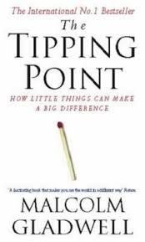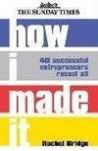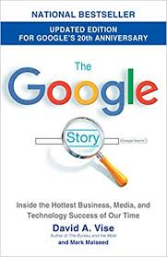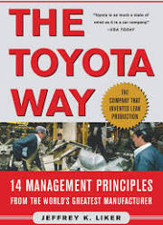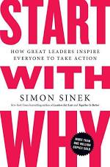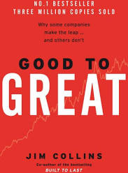

Bloomberg Businessweek, Consumer Reports, The Economist, Fast Company, Forbes Magazine, Fortune Magazine, Harvard Business Review, Inc Magazine, MIT Sloan Management Review, MIT Technology Review, Quartz, Wired, Financial Times, Times.

https://www.ted.com/talks/debbie_millman_how_symbols_and_brands_shape_our_humanity
https://www.ted.com/talks/patrick_mcginnis_how_to_make_faster_decisions
https://www.ted.com/talks/markus_mutz_how_supply_chain_transparency_can_help_the_planet
https://www.ted.com/talks/michael_c_bush_this_is_what_makes_employees_happy_at_work
https://www.ted.com/talks/wendy_woods_the_business_benefits_of_doing_good#t-882334

 | China on four Wheels  Be your own Boss  Dragons’ Den  Million Pounds Selfie self-off  The Apprentice | Freakonomics  The Big Short  Wall Street Crash  Panorama  Dispatches

