**Welcome to A-level Sociology**

**Essential work Transition Work**

You have chosen a subject that will ‘keep you on your toes’ and make you think in ways you couldn’t imagine. You will certainly have a very different outlook on society by the end of your course.

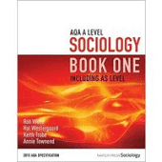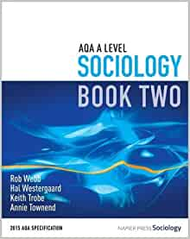

**Overview of the course:**

This is a two-year course which ends with **three** two-hour papers each carrying an equal weighting towards your final A-level grade (A*-E).

Topics we will cover will include:

Year 12 Year 13

Theories of Sociology Crime and Deviance

Methods of Sociology Beliefs in Society

Families & Households Methods of Sociology

Education Theories of Sociology

Look at the specification for more detail about these topics. You can find this at: <https://filestore.aqa.org.uk/resources/sociology/specifications/AQA-7191-7192-SP-2015.PDF>

You will be expected to know and understand **(AO1)** the information about the topics, to be able to apply **(AO2)** that knowledge and understanding and to be able to analyse and evaluate **(AO3)** that knowledge and understanding.

***Task 1***

Read the specification carefully and make a note below of the sections there are to each topic:

Education……………………………………………………………………………………..………………

.………………………………………………………………………………….………………………………

…………………………………………………………………...................................................................

Theory and Methods (Year 1)…………………………..…………………………………………………

………………………………………………………………………………………………….………………

…………………………………………………………………...…………………………………………...…

Families and Households….………………………………………………………………………………..

…………………………………………………………………………………………………........................

…………………………………………………………………………………………………........................

Beliefs in Society……………………………………………………………………………………………..

………………………………………………………………………………………………….………………

…………………………………………………………………..……………………………………………..

Crime and Deviance ………………………………………………………………………………………

…………………………………………………………………………………………………………………..

………………………………….……………………………………………………………………………….

Theory and Methods (Year 2) ………………………………………………….…………………………

…………………………………………………………………………………………………………………..

…………………………………………………………………………………………………………………..

What do you think ‘Methods in Context’ means?

***Task 2***

Choose something from the Reading and Watching List that you are going to report on in your first Sociology lesson.

***Task 3***

Each group of statements represents a sociological theory. Say which ONE statement out of each group you agree with and give reasons why you have chosen it.

**Slide 1 Statements:**

1. Men dominate all aspects of society.
2. Gender inequalities exist.
3. Women are systematically disadvantaged.
4. The new man theory is a myth
5. The Feminist theory is outdated in a post-modern society .

I agree with …………………………………………………………………………………………………..

…………………………………………………………………………………………………………………..

…………………………………………………………………………………………………………………..

**Slide 2 Statements:**

1. Society exists in a state of balance.
2. Society works for the benefit of all.
3. Structures in society exist to help people and the smooth operation of society.
4. We live in a democracy.
5. People are judged only in terms of their merit / skills / intelligence.

I agree with …………………………………………………………………………………………………..

…………………………………………………………………………………………………………………..

…………………………………………………………………………………………………………………..

**Slide 3 Statements:**

1. Life is unfair.
2. People are not paid enough.
3. The world is run for a very small group of people.
4. Most people cannot see that they spend their entire lives being exploited.
5. Our current system for organising the economy does not work.

I agree with …………………………………………………………………………………………………..

…………………………………………………………………………………………………………………..

…………………………………………………………………………………………………………………..

***Task 4***

Watch the following clip and jot down 5 things that tell you what Sociology is.

https://www.youtube.com/watch?v=YnCJU6PaCio

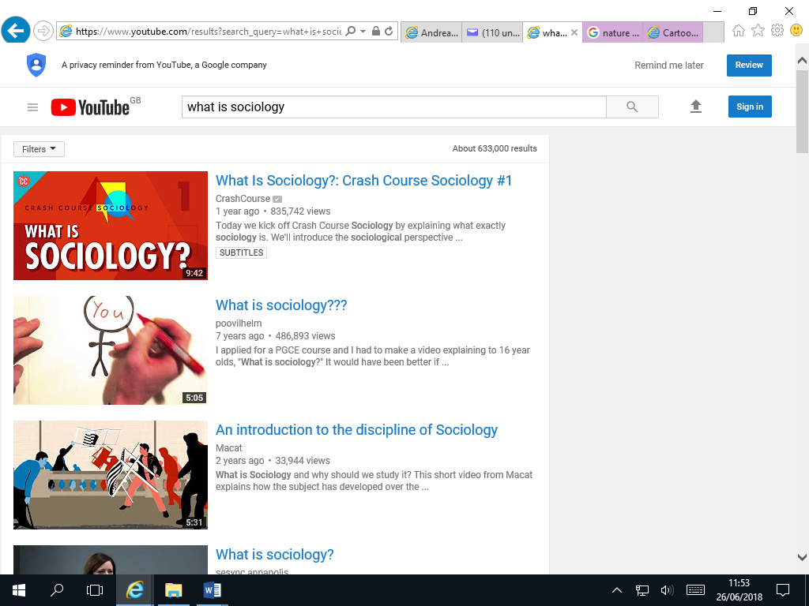

[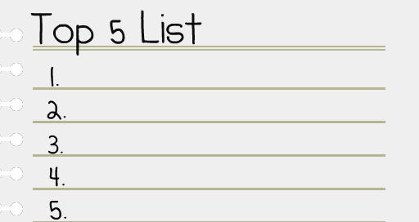](https://www.google.com/url?sa=i&rct=j&q=&esrc=s&source=images&cd=&cad=rja&uact=8&ved=2ahUKEwjqrrnnmvHbAhXiJsAKHVe2D3UQjRx6BAgBEAU&url=https://melissafoster.com/time-management-tips-following-through-commitments-limited-time/&psig=AOvVaw2_2_YFqRQyGw9LEUIgtpZI&ust=1530098356438301)

An Introduction to A-level Sociology

[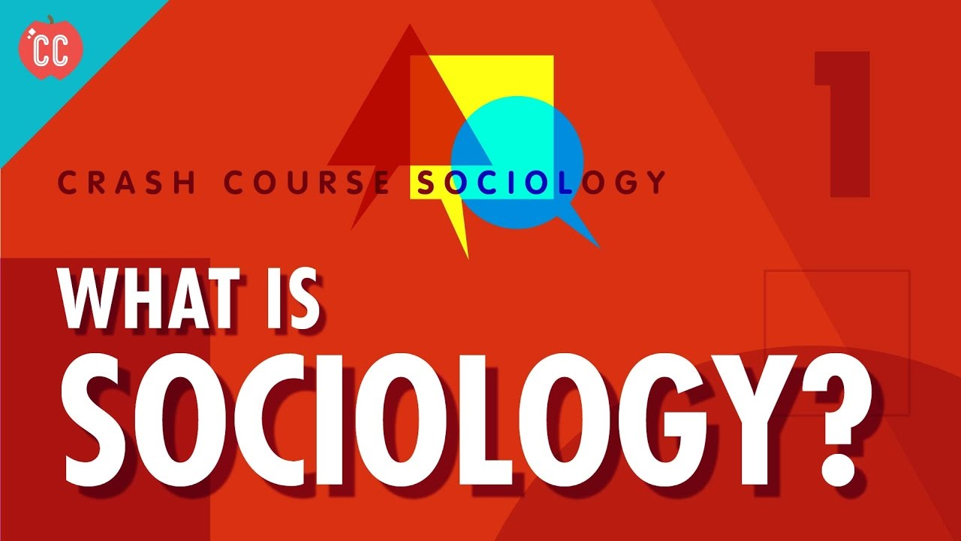](https://www.google.com/url?sa=i&rct=j&q=&esrc=s&source=images&cd=&cad=rja&uact=8&ved=2ahUKEwjNv7T5kPHbAhVG1RQKHbzMCg8QjRx6BAgBEAU&url=https://www.youtube.com/watch?v%3DYnCJU6PaCio&psig=AOvVaw35_fxVT9ifNaQlRES85LAw&ust=1530095622186461)

**Sociology** is the study of human social life. There are many different aspects of Sociology to address, so you must be curious and attentive to looking at the world in a different way!

[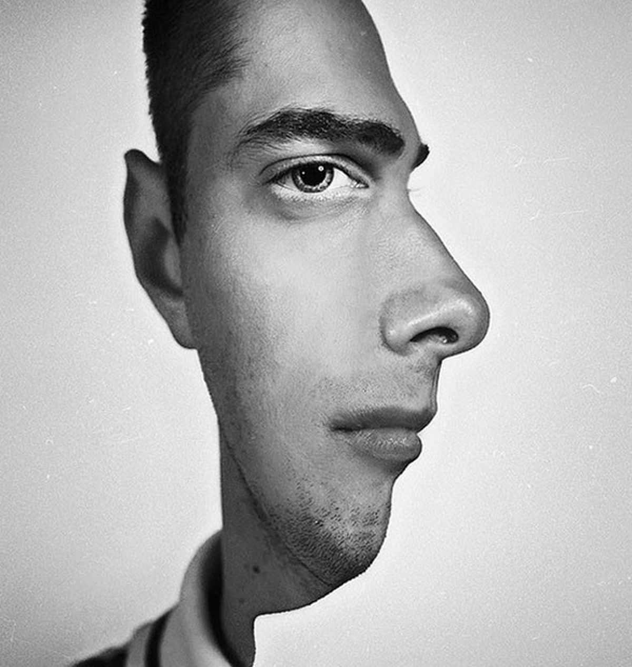](https://www.google.co.uk/url?sa=i&rct=j&q=&esrc=s&source=images&cd=&cad=rja&uact=8&ved=2ahUKEwjigqiopOLbAhVMVxQKHWZzBw0QjRx6BAgBEAU&url=https://www.seenox.org/incredible-visual-illusions-will-make-you-feel-like-on-drugs/&psig=AOvVaw3FBeiv_qt64EG9G-NAIyRO&ust=1529585523353145)

Look at this photograph; not everything is as it seems!

There is usually another way of looking at things – and that is what we do as sociologists.

We take normal, taken-for-granted life and turn it upside down, looking for meanings. And very often we end up seeing things very differently.

*Social Change*

The social world is changing. Some argue it is growing; others say it is shrinking. The important point to grasp is: society does not remain static over time; it constantly changes - through decades and centuries and across countries, societies.

***Task 5***

Think of 3 different ways society has changed over the last 100 years. Try to be specific about the change eg. homosexuality is no longer illegal.

…………………………………………………………………………………………………………………………………………………………………………

…………………………………………………………………………………………………………………………………………………………………………

…………………………………………………………………………………………………………………………………………………………………………

Now, name 3 ways in which British society is different to another (America, Italy etc.)

………………………………………………………………………………………………………

………………………………………………………………………………………………………

………………………………………………………………………………………………………

………………………………………………………………………………………………………

…………………………………………………………………………………………………………………………………………………

…………………………………………………………………………………………………………………………………………………

***Task 6***

Why do you think has society changed? Why are societies different?

…………………………………………………………………………………………………………………………………………………………………………

…………………………………………………………………………………………………………………………………………………………………………

…………………………………………………………………………………………………………………………………………………………………………

…………………………………………………………………………………………………………………………………………………………………………

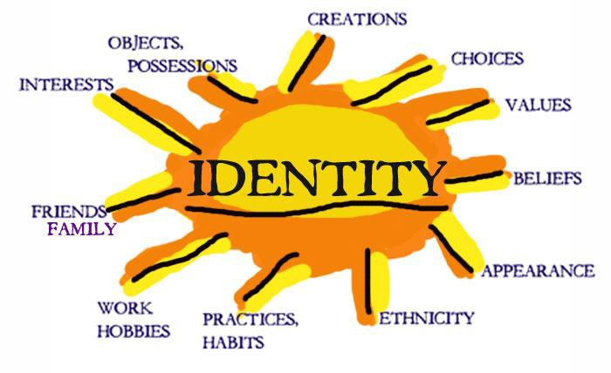**Identity**

Who are you? Are you part of a group, an individual, a student, a sister, a brother?

**Identity** is about how we

see and define ourselves –

our personalities – and how

other people see and define us. Many aspects of our individual identity are influenced by

**agencies of socialisation**. These are structures or groups of people.

***Task 7***

Suggest four examples of structures or groups of people that impact upon you:

……………………………………………………………………………………………………………………………………………………………………

……………………………………………………………………………………………………………………………………………………………………

……………………………………………………………………………………………………………………………………………………………………

……………………………………………………………………………………………………………………………………………………………………

……………………………………………………………………………………………………………………………………………………………………

……………………………………………………………………………………………………………………………………………………………………

……………………………………………………………………………………………………………………………………………………………………

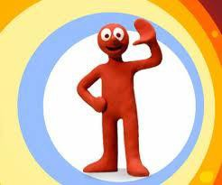Individuals are like moulded putty, squished and squashed by society and its **structures**, but there are decisions we make that are driven by internal motivations. Behaviour that comes from within us – decisions we make in order to do things - is called **agency**. Agency behaviour is meaningful and a reflection of self-will. Sometimes we can challenge and oppose structures, and in this way we help construct a part of our identity.

***Task 8***

List three agency decisions you have made or will make today.

1. ………………………………………………………………………………………………………………

2. ………………………………………………………………………………………………………………

3. …………………………………………………………………………………………………………………

***Task 9***

Make a poster of how your identity is shaped by factors in your life.

Consider **agency** factors and **structural** factors.

Brainstorm some ideas first on what you can include in your poster.

……………………………………………………………………………………………………………………………………………………………………

……………………………………………………………………………………………………………………………………………………………………

……………………………………………………………………………………………………………………………………………………………………

……………………………………………………………………………………………………………………………………………………………………

……………………………………………………………………………………………………………………………………………………………………

……………………………………………………………………………………………………………………………………………………………………

……………………………………………………………………………………………………………………………………………………………………

……………………………………………………………………………………………………………………………………………………………………

***Nature vs Nurture – The Big Debate***



There are many ways of explaining why certain people do things in certain ways. For example, biologists think that people behave as they do because they are controlled by nature. This is known as **Nature theory**. Humans are compared to animals and seen to act on **instinct**.

Sociologists believe that people behave as they do because they are taught how to behave. For example, the sociologist Michael Haralambos states, ‘Human beings learn their behavior and use their intelligence whereas animals simply act on instinct.’ This is known as **Nurture theory**. Nurture means the way you are brought up. It is also a reference to **socialization**, the lifelong process by which we learn our culture, values, norms and how to behave.

***Task 10***

Write down a list of things that you were taught by other people about how to behave eg. how to speak etc.

………………………………………………………………………………………………………………………………………………………………

………………………………………………………………………………………………………………………………………………………………

………………………………………………………………………………………………………………………………………………………………

………………………………………………………………………………………………………………………………………………………………

………………………………………………………………………………………………………………………………………………………………

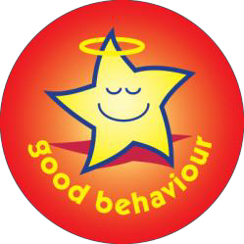Sociologists reject nature theories for two particular reasons. If people behaved as they do because of nature, they would all act the same as each other. The following reasons show why people do not all act the same:

1. ***History***: people acted differently in the past from the way that they do today. They had different ideas and different beliefs.
2. ***Anthropology:*** this is the study of different human societies. Wherever you go in the world, people act differently from the way they do in Britain.

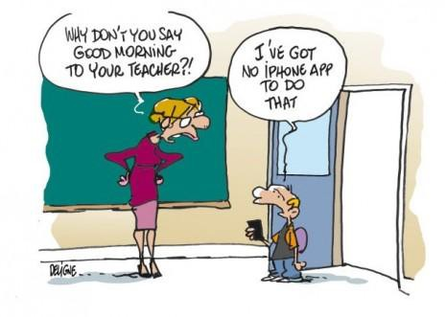**Social behaviour and culture**

Sociology is the study of human groups and social life in modern societies. Sociology recognises that as members of society we have to learn social behaviour and this is done through a variety of social institutions and social groups right throughout our lives.

|  |
| --- |
| ***Task 11***  WHAT MAKES US HUMAN?   * Are we meant to live alone? * What would a person be like if they grew up without human contact? * What would a person be like if they were then introduced into a society? * Do we need a society in which to survive? * Can someone be truly human if they grew up without human contact? * Are we ruled by our instincts? (An instinct can be defined as a complex, unlearned pattern of behaviour that is universal in a species).   Watch the video and compare how, as children, we behave and how Oksana behaves. What has been the impact of the lack of human contact?  <https://www.youtube.com/watch?v=nv3ocntSSUU> |

It should have become clear that humans, more than most other animals, are dependent upon other humans for the most basic needs such as food and shelter.

We do not arrive in this world equipped with a collection of instincts inherited from our parents that will enable us to survive in a potentially hostile environment.



Virtually all the things that we do have to be learned from others, for example walking, speaking, knowing what to eat, defending ourselves etc. A desert island baby is unlikely to survive, therefore we need other people.

We have now established an important principle. Human behaviour is largely learned through a process called ***socialisation.*** Therefore what is termed as **culture,** which is our way of life, including the ways in which we behave relates to:

- the language we speak

- the clothes we wear

- the food we eat and whether we eat it with knives, forks and spoons

- the homes we live in

- to the things we believe about the origins of life

- what is good or bad

- or the ways in which we should be governed.

The above are all acquired from other people (this involves the process of **socialisation** into the **culture** of our society)

|  |
| --- |
| ***Task 12***  Using the above list, describe the British culture. |

It is through our membership of social groups that we acquire an understanding of the ways in which behaviour is patterned and organised and of the **values**, customs, **norms** and **roles** of our society. Sociologists refer to this as **culture** — the learned, shared behaviour of members of society. Culture is a social blueprint, a guide for living. It refers to all the aspects of human behaviour that are learnt rather than genetically transmitted. The following activity shows you the importance of culture.

A **subculture** is a culture within a broader mainstream culture, with its own separate values, practices, and beliefs eg. Bikers, goths, skateboarders, scousers, yuppies, hippies etc.



*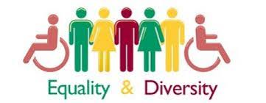****Task 14: Essay***

A-level Sociology is all about essay writing, a hugely important skill. This essay is designed to allow you to demonstrate your sociological understanding and writing skills.

You will be assessed on the quality of your written style, the level to which you have understood and can use sociological concepts, your organisational skills and ability to follow instructions.

|  |
| --- |
| **Essay title:**  **Evaluate the view that society is becoming more equal in the 21st century.**  You will need to pay particular attention to the notes which follow on socialisation and role.  You should think firstly about what is meant by ‘equality’. Consider ways you think equality has been achieved and give examples. Try to think widely and consider global issues – it may help to make comparisons with other countries/societies.  To evaluate, you need to ‘weigh up’ and make a judgement so you also need to think about how some groups in society may still experience inequality, why this might be the case and whether equality can /should be achieved. |

Your essay should have:

* Clear paragraphs, an introduction and conclusion
* Accurate spelling, punctuation and full sentences
* Correct use of grammar
* Accurate phrasing
* Discuss different types of equality eg. gender, social class, ethnicity

Your essay should be at least 500 words and ***hand written***.

You should hand in your essay when directed on your return to 6th Form.

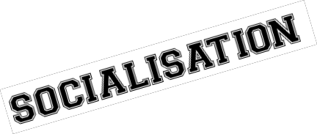

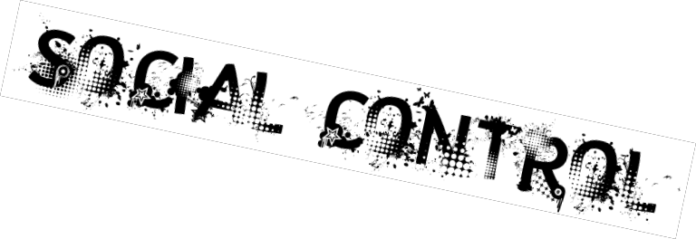

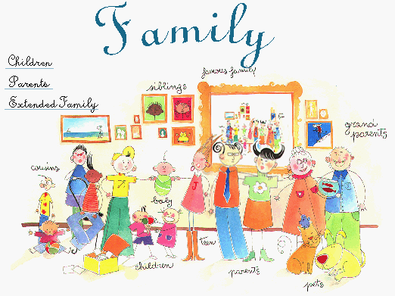Socialisation is the term that sociologists use to describe the life-long process of learning the culture of any society. Culture is socially transmitted from one generation to the next through the process of socialisation. The American sociologist Charles Cooley (1864–1929) distinguished two types of socialisation: **primary** and **secondary**. These two forms of socialisation are defined partly in terms of the particular groups or ‘agencies’ in which they occur:

***Primary socialisation***

The family is the main agency where an individual learns many of the basic lessons for life such as language, how to act as a boy or a girl, how to share and how to love.



***Secondary socialisation***

Associated with the later stages of identity formation, from later childhood and continuing through adulthood. The school is an important example of an agency of secondary socialisation, but all formal organisations, including religion and work, are influential.

***Task 15***

List 2 ways in which your family teach you something. Similarly, list two ways in which

school teaches you something **(something other than subjects!).**

………………………………………………………………………………………………………………………………………………………………

………………………………………………………………………………………………………………………………………………………………

………………………………………………………………………………………………………………………………………………………………

………………………………………………………………………………………………………………………………………………………………

Socialisation is not only the process by which we learn the culture of our society; it is also a mechanism of **social control**.

This refers to methods used to persuade or force individuals to conform to those values, norms and patterns of behaviour which the culture of their society requires. Social control involves the use of rewards and punishments. Sociologists refer to these as sanctions. These may be either positive sanctions (rewards) or negative sanctions (various types of punishment):

**Positive sanctions** may range from gifts of sweets from parents to children, to merits and prizes at school, to promotion at work or to knighthoods and medals.

**Negative sanctions** may range from expressions of disapproval, physical punishment, being ridiculed or gossiped about, dismissal from work to being fined or imprisoned.

***Task 16***

List and briefly explain three positive and three negative sanctions which affect the way you behave in your daily life:

POSITIVE

**1. …………………………………………………………………………………………………**

**2. …………………………………………………………………………………………………**

**3. …………………………………………………………………………………………………**

NEGATIVE

**1. …………………………………………………………………………………………………**

**2. …………………………………………………………………………………………………**

**3. …………………………………………………………………………………………………**

***Key Concepts in Socialisation and Culture***

*Norms*

**Norms** are social rules which define correct and acceptable behaviour in a society or social group to which people are expected to conform. They are essential to human society. They guide and direct our behaviour and allow us both to understand and predict the behaviour of others.

Norms exist in all areas of social life. In Britain, being late for work or an appointment; jumping queues in supermarkets; laughing during funerals; walking through the streets naked or never saying hello to friends are likely to be seen as rude, annoying or odd because they are not following the norms of accepted behaviour.

Norms are usually enforced informally—by the disapproval of other people, embarrassment, or a ‘telling off’ from parents.

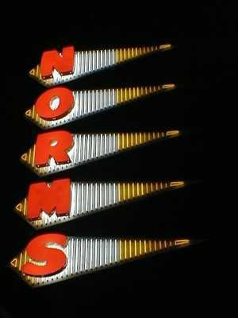

***Task 17***

Think of some norms for each of these situations.

School: ………………………………………………………………………………………………………………

…..…………………………………………………………………………………………………………………………..

……………………………………………………………………………………………………………………………….

Home: ……………………………………………………………………………………………………………….. ………………………………………………………………………………………………………………………………………………………………………………………………………………………………………………………………………………………………………………………………Friend’s house: ………………………………………………………………………………………………………………………………

………………………………………………………………………………………………………………………………………………………………

………………………………………………………………………………………………………………………………………………………………..

**Task 18**

In Sociology, there are three main different sociological perspectives, or ways of looking at society:

1. **Functionalists**: these sociologists believe society runs smoothly, and is made up of different parts which all work together to keep society stable. They believe people agree on what is important (there is a value consensus) and people generally conform to the norms of society. They tend to focus on the positive functions of different parts of society. Watch this video to find out more: <https://www.youtube.com/watch?v=-83vVeSC2_g>
2. **Marxists**: based on the ideas of Karl Marx, they focus on inequalities based on social class (how much or little money someone has). They believe this is the main inequality in society. They argue there are two main classes: the working class (proletariat) and ruling class (bourgeoisie) and believe the ruling class own and exploit the workers, treating them badly and giving them low pay so they can make more money for themselves. Watch this video and find out more: <https://www.youtube.com/watch?v=fSQgCy_iIcc>
3. **Feminists**: see gender inequality, inequality between men and women, as the main inequality in society. They argue women are treated badly and exploited by men, and that society is patriarchal (male-dominated). Watch this video to find out more: <https://www.youtube.com/watch?v=D6Dl-9pSW-4>

**Complete the table to summarise the different perspectives:**

|  |  |  |
| --- | --- | --- |
|  | Summary | Image |
| Functionalism |  |  |
| Marxism |  |  |
| Feminism |  |  |

***Task 19: Recap***

List the key words you have learned so far with their definitions in the table.

|  |  |
| --- | --- |
| *Key Term* | *Definition* |
| Sociology |  |
| Identity |  |
| Structure |  |
| Agency |  |
| Nature/Nurture |  |
| Socialisation |  |
| Culture |  |
| Norms |  |
| Values |  |
| Status |  |
| Role |  |