Sociology Bridging Work (Desirable)
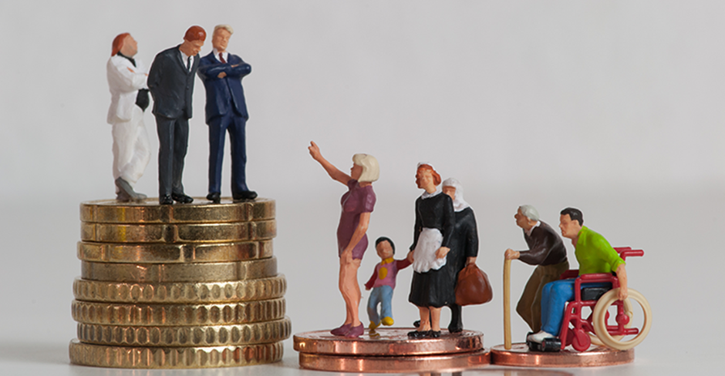
Name:

Within this booklet we are going to be looking at whether ‘Society in the UK is fair’. Debating key areas of society will really help you in preparing for A Level Sociology.

Key question: is Britain fair?

Two babies are born on the same day. Do they have an equal chance of…
… being healthy?
… going to university?
… getting a well-paid job?
… avoiding prison?
… succeeding in school?
- One third (30%) of children in Britain live in poverty
- People born into the most deprived (poor) areas of the UK are likely to live, on average, 10 years less than those in affluent (well off) areas
- Only 30% of those receiving Free School Meals (FSM) (low family income) achieve a pass in English and Maths at GCSE compared to 60% of those who do not receive FSM
- Only 7% of the population go to fee-paying schools, but they make up 42% of students at Oxford and Cambridge and dominate top jobs in law, journalism, politics and health
- Last year, there was a 13% increase in food bank use
These statistics paint a bleak picture of whether or not Britain is a fair society. Before we engage in the debate of whether or not Britain is fair, we must define what we mean by this.
In Sociology, a ‘fair’ society is a society where everyone has equality of opportunity – everyone has an equal chance of achieving success and their background does not determine this. Sociologists call this a ‘meritocracy’ – a society where status is based on merit (hard work and talent) rather than the position you are born into. In a meritocracy, effort should be the only factor determining the position someone gains in life.
Functionalists believe contemporary (modern) Britain is a meritocracy and that success is determined only by hard work.
Quick check: look at the following cartoons and reflect on the statistics above. In your opinion, does everyone have an equal chance to succeed? Why or why not? Write your response in the box provided.
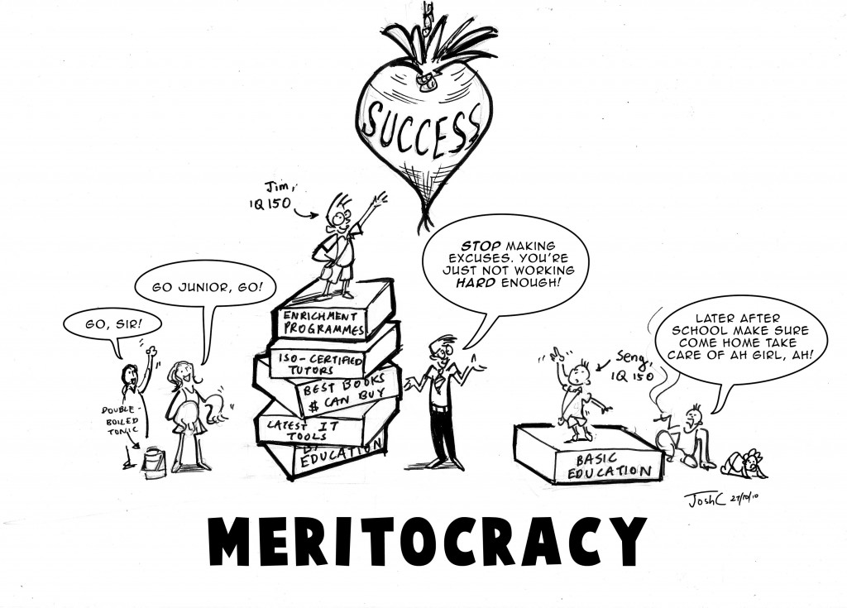

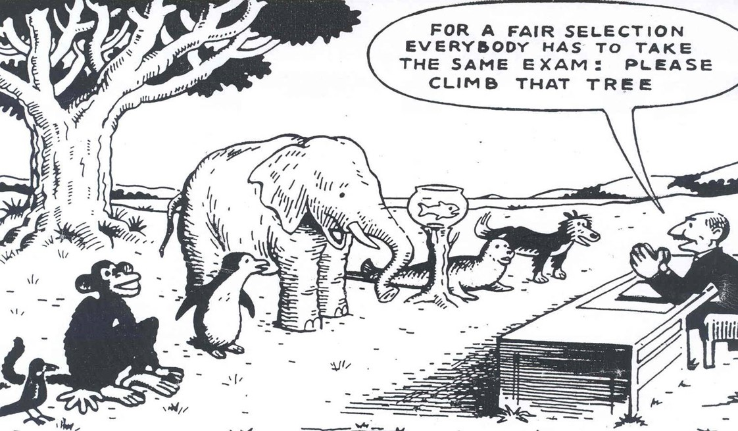

Marxists disagree with functionalists, arguing society is not a meritocracy. They believe those born into the working class (poorer members of society) have less chance of succeeding in life. They believe the upper class (the rich) have a much higher chance of succeeding and dominate the top positions in society.
Feminists also disagree, arguing women have less chance of succeeding than men. They argue society is patriarchal, meaning that men have an inbuilt advantage compared to women, and that women are disadvantaged and oppressed.
Other sociologists believe people from ethnic minority backgrounds are disadvantaged, due to individual and institutional (embedded) racism.
Is the education system fair?
- Education policy institute found disadvantages children were 18 months behind their peers by the time they took their GCSEs
- More affluent (advantaged) students have heard 30 million more words than disadvantaged students by the time they are 5
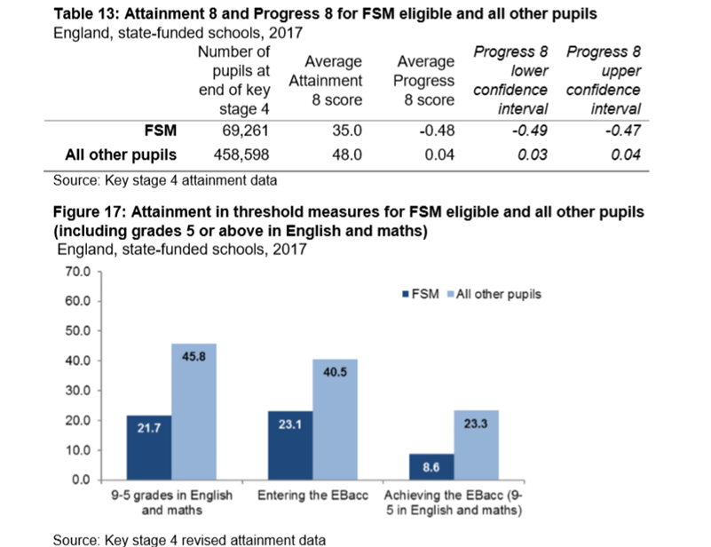
Pupils can claim Free School Meals if their household income is less than £16,000, so it is used as a measure of social class or poverty.
- What percentage more students not on FSM achieve a grade 5 in English and Maths compared to students on FSM?
- What does this show about which students do better in education?
- Can you think of any reasons for this?
At school, children from different backgrounds receive very different outcomes in education. Here are some of the main reasons:
- Material deprivation – students may lack the physical resources they need to study, like books and internet access. How might this impact their exam results?
- Labelling – students may be labelled as lower achieving by teachers. This is when teachers attach a label to students and treat them differently. They may see working class students as less motivated, less able and less hard working. How might this impact their results?
- Parental attitudes – parents from working class backgrounds may be less involved and less engaged in their children’s education, possibly because they had a bad experience of school themselves.
Many wealthy parents can afford to send their children to independent schools too.
Some sociologists also argue ethnic minorities have a worse experience of education, because they experience racism and institutional racism. Some also argue these inequalities are due to differences in the family structures of different ethnicities.
Research task: read the articles and watch the documentaries and listen to the podcast to get a better understanding of the inequalities in education. Use the information to write 500 words explaining why education in contemporary Britain may not be fair, including which groups may be more disadvantaged.
Source | Key points
Podcast: Professor Cecil Wright discussing the ethnic inequalities in education, including her experiences at school

https://www.spreaker.com/user/thesociologyshow/prof-cecile-wright
Article: Diane Reay explaining the unequal treatment of working class children in education

https://www.theguardian.com/education/2017/nov/21/english-class-system-shaped-in-schools

Report (just read the executive summary): The impact of attitudes and expectations on educational attainment

https://www.jrf.org.uk/sites/default/files/jrf/migrated/files/education-young-people-parents-full.pdf
Documentary: Too Poor for Posh School?
https://www.youtube.com/watch?v=MWYaoWPdUOI
Clip: Should we abolish private schools?

https://www.youtube.com/watch?v=pN36jVSp1x0&t=7s
Documentary: Professor Green, Living in Poverty
https://www.youtube.com/watch?v=PopPlAXcWDE

Write your response here:

Is family life fair?
If we were to rewind to the 1950s, we would see that family life used to be very unequal. Women were expected not to have a paid job, but to complete all the housework and childcare, whilst men would go out and work. Look at this page from a home economics textbook in the 1950s:
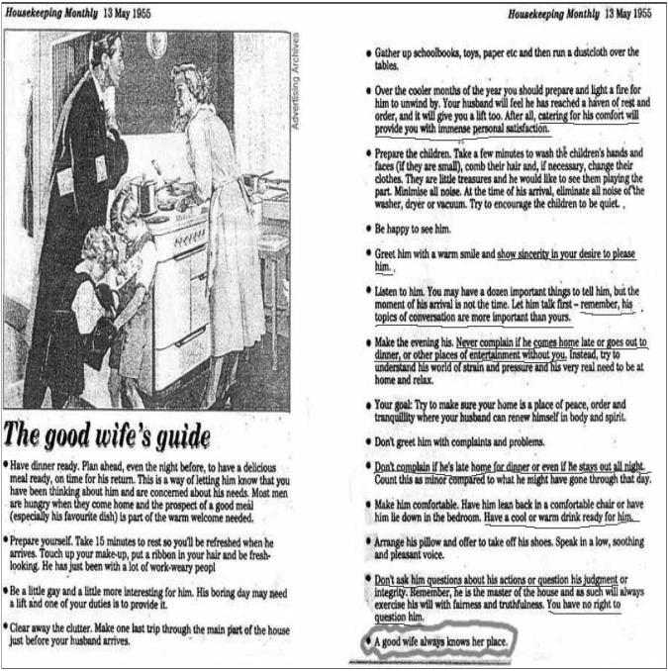
- What does this show about the role of women in the family?
- What would feminists think about this?
- How has this changed?
Today, men and women are more equal. Women are likely to have a paid job as well as men, and men and women are both likely to contribute to family life and tasks. However, there are still inequalities between men and women in the family. Men are usually paid more than women, and so have more power, and women often still complete up to 60% more housework and childcare than men.
Many women must perform the ‘double shift’ – which means doing two shifts of work, one in their paid role, and one at home. Some sociologists also argue that women perform more emotional labour – remembering birthdays, comforting people when they are upset, scheduling appointments and so on.
In your opinion, should women do more housework and childcare than men? Why/ Why not?

Research task: read/ watch/ listen to the sources below and record the key points. Then write 500 words explaining whether or not family life in the UK is fair in your opinion. Try to use evidence and examples where possible.
Source | Key points
Article: Why is there still a housework inequality gap?
https://www.theguardian.com/inequality/2018/feb/17/dirty-secret-why-housework-gender-gap
Article: What is emotional labour?

https://www.bbc.co.uk/bbcthree/article/5ea9f140-f722-4214-bb57-8b84f9418a7e

Clip: Sociologist Arlie Hoschild discussing the second shift
https://www.youtube.com/watch?v=mvzE6zYkEQY
Documentary: What stands in the way of women becoming equal to men?

https://www.youtube.com/watch?v=ayj9EVc2ZLI
Article: The ‘tradwife’ movement, encouraging young women to revert to 1950s expectations

https://www.theguardian.com/fashion/2020/jan/27/tradwives-new-trend-submissive-women-dark-heart-history
Write your response here:

Is the criminal justice system fair?
The criminal justice system refers to all parts of the system that creates and enforces the laws. This includes the government, who create and pass laws, police officers, who enforce the laws, judges, who decide sentences for those convicted of crimes and prison and probation officers.
Here are some statistics on the criminal justice system:
- Black people are 9 times more likely to be stopped and searched by the police
- The police are 3 x more likely to use force against black people
- Young, black males are overrepresented in prison
There are many explanations for these statistics, summarised below:
- Institutional racism: this means racism embedded in the criminal justice system. The murder of Stephen Lawrence in 1993 by five white youths led to the Macpherson Report of 1998 and revealed the huge extent of institutional racism in the police force – the report recommended increasing the diversity of the police force and establishing an independent police complaints service, but there are still concerns of institutional racism in the police today.
- Family structure: Tony Sewell argues lone parent families are likely to lead to black boys being involved in crime
- Poverty: people from some ethnic minority backgrounds are more likely to live in poverty and therefore more likely to commit crime.
The treatment of different groups, particularly different ethnicities, in the criminal justice system demonstrates one of the main inequalities which remains an issue in the UK, affecting people’s life chances significantly.
This results both in it appearing that more ethnic minority groups, especially black people, commit more crime (when they may just be targeted more by the police) and ethnic minority individuals not being taken seriously as victims of crime.
In addition, feminists argue women are often not taken seriously as victims of crime like domestic violence and sexual assault. They argue the patriarchal criminal justice system are keen to blame women for making themselves into victims of these crimes by dressing/ acting a certain way.
Even though there are a specific set of laws that everyone must follow, sociologists argue that these rules and the enforcement of the law are applied differently, unequally, to different groups of people, resulting in these inequalities.

Research task: read/ watch/ listen to the sources below, and write 500 words describing whether or not the criminal justice system is fair and why/ why not.

Source | Key points
Documentary: Stephen Lawrence, Time for Justice

https://www.youtube.com/watch?v=ZsHwKPE0mjU
Article: Institutional Racism 20 years after Stephen Lawrence’s murder

https://www.theguardian.com/uk-news/2019/feb/22/institutional-racism-britain-stephen-lawrence-inquiry-20-years

BBC Teach Clip: Institutional Racism

https://www.youtube.com/watch?v=4XL5f45TJgM
Article: David Lammy describing why stop and search is unfair

https://www.theguardian.com/law/2018/oct/13/stop-and-search-is-unjust-unfair-ineffectual-david-lammy
Clip: Tony Sewell explaining his perspective that lone parent families lead to black boys being involved in gangs

https://www.youtube.com/watch?v=tU1tMhvf3OQ&t=11s
Clip: David Lammy discussing racial bias in the Criminal Justice System

https://www.youtube.com/watch?v=RvMouTYuw7g
Write your response here:

Conclusion: How can we make society fairer?
Analysing the negative aspects of society can paint a bleak picture of both society and Sociology, but an important part of sociology is considering society’s problems in order to think about how we can improve society.
Making society better and more equal starts with individuals – how we treat other people, interact with others and what we expect and ask of others.
Use this space to record what you will do differently to try to improve society. I have written some examples to help you.
Examples:
- Be kind to everyone, regardless of their background and my differences
- Make sure housework is divided equally between myself and my siblings

There are also bigger changes we can encourage and lobby for, for example, by writing to your local Member of Parliament. These could be: reforming the criminal justice system, abolishing private schools or introducing a higher minimum wage. Us the space below to write some ideas of what bigger issues you would like to change to make society fairer.

